ENGLISH
for
C΄ CLASS
LEVEL B1+

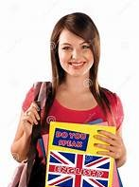

Cosmas Markis (EFL Teacher)
3rd Junior High School of Preveza

CONTENTS
UNIT 1: GREAT PERSONALITIES……………………p.1-12
UNIT 2: BEING CONNECTED………..……………....… p.13-20
UNIT 3: SHOP TILL YOU DROP!………………..……..…. p.19-27
UNIT 4: THE SILVER SCREEN ……………………..…..p.28-38

UNIT 1: GREAT PERSONALITIES
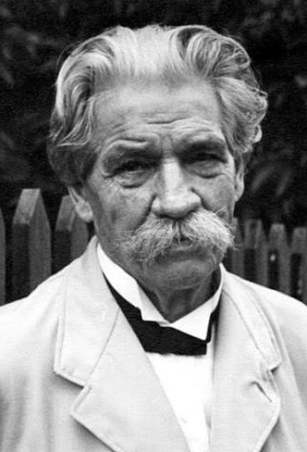
Albert Schweitzer: A life of dedication & hope
Albert Schweitzer was a truly remarkable man who spent his entire life helping others. Born in 1875 in Alsace, a region between France and Germany, he grew up to become a successful philosopher, theologian, and musician. By the time he was thirty years old, he was already famous across Europe for his books on religion and his talent for playing the organ. However, Schweitzer felt that words and music were not enough. He wanted to take direct action to make the world a better place.
In 1905, he made a decision that surprised his friends and family. He decided to study medicine so he could go to Africa as a doctor. He believed that Europeans had a duty to help the people living in colonized lands. After completing his difficult medical studies, Dr. Schweitzer and his wife, Helene, traveled to Lambaréné in Gabon, Africa, in 1913.
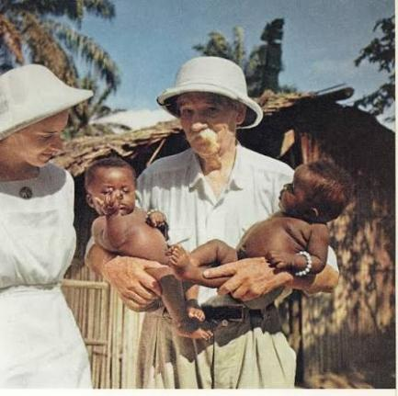
When they arrived, they faced incredible challenges. There was no hospital, so they had to use an old chicken coop as a temporary shelter to treat patients. The local people suffered from terrible tropical diseases, and many families lived in extreme poverty. Furthermore, running a medical center required a lot of money. Schweitzer often worried about the debts he had to pay to buy expensive medicines and medical tools. To raise money, he frequently traveled back to Europe to give speech presentations and play organ concerts.
Despite these struggles, Dr. Schweitzer never gave up. He was ready to confront any problem, from dangerous diseases to the lack of construction materials. Over the years, he built a large, modern hospital that saved thousands of lives. His hospital was different because he allowed patients to bring their families and animals with them. He believed this was a much more fair and respectful way to treat the local people and their traditions.
During his time in Africa, Schweitzer developed a famous philosophy called "Reverence for Life." He argued that all living things—humans, animals, and plants—have a right to live and deserve our protection. This beautiful idea inspired millions of people around the globe to think about ecology and human rights long before modern environmental movements started.
In 1952, Albert Schweitzer received the Nobel Peace Prize for his humanitarian work. He used the prize money to expand his hospital and build a special village for people suffering from leprosy. He continued working as a doctor and writing books until he passed away in Gabon in 1965 at the age of ninety. Today, his life remains a powerful example of how one person's dedication can bring hope to the world.
- Choose the correct answer for each question based on the text.
1. Why did Albert Schweitzer decide to study medicine when he was 30 years old?
- A) Because he could not find a job as a musician.
- B) Because he wanted to help people in Africa.
- C) Because his family forced him to change his career.
2. What was the first temporary shelter Dr. Schweitzer used to treat patients in Gabon?
- A) A modern hospital room
- B) A large tent
- C) An old chicken coop
3. How did Schweitzer manage to pay off the debts for the hospital's expensive medicines?
- A) He asked the Nobel Peace Prize committee for a loan.
- B) He sold his house in France and became poor. 1
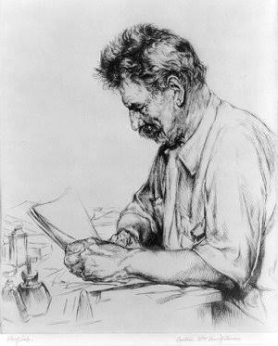
- C) He returned to Europe to give concerts and speeches to raise money.
4. Why was Dr. Schweitzer’s hospital considered fair and respectful to the local people?
- A) It allowed patients to bring their families and animals with them.
- B) It offered free food to everyone in the country.
- C)It only treated people who lived in extreme poverty.
5. What is the main idea behind Schweitzer's philosophy "Reverence for Life"?
- A) Only human beings deserve to have human rights.
- B) All living things—humans, animals, and plants—deserve protection.
- C) People must move away from cities to live in nature.
6. What did Dr. Schweitzer do with the money he received from the Nobel Peace Prize?
- A) He used it to retire and stop working as a doctor.
- B) He expanded his hospital and built a village for leprosy patients.
- C) He bought a massive collection of new musical instrument

- Complete with the right word in bold from the text.
- Many families in the region live in extreme ………………………………, without enough money for food or clean water.
- Albert Schweitzer spent his life doing ………………………………………. work, helping thousands of sick people in Africa.
- It is our moral ……………………………… to protect the environment and take care of our planet for future generations.
- After buying the expensive medical equipment, the hospital was left with massive ……………………………. to pay off.
- She showed ………………………. courage when she decided to enter the burning building to save the trapped puppy.
- Dr. Schweitzer's deep ……………………………………… for life meant that he respected and protected all living creatures, including plants and insects.
- The young doctor had to …………………… many dangerous situations, including tropical diseases and heavy storms.
- It was a long and difficult …………………………………………….. to build the clinic, but they never stopped trying.
9. The teacher's dedication ……………………………………… many students to choose careers in medicine and social work.
10. The community was deeply saddened when the beloved village doctor………………………………… at the age of ninety.

CLAUSES OF CONTRAST
Although Albert faced a lot of struggles, he never gave up.
Even though Albert faced a lot of struggles, he never gave up.
Albert faced a lot of struggles, however, he never gave up
Albert faced a lot of struggles, nevertheless, he never gave up.
In spite of facing a lot of struggles / the struggles he faced, Albert never gave up.
Despite facing a lot of struggles / the struggles he faced, Albert never gave up.
Make sentences as above.
- Although he had a career as a musician, he decided to study medicine.
- Albert could have a comfortable life. However, he decided to help the poor.
- Despite all the difficulties, Albert managed to succeed.
- Although he had retired, he kept working as a doctor.
Think of and write 3 contrast sentences, using different ways. …………………………………………………………………………………………………………………………………………………………………………………………………………………………………………………………………………………………………………………………………………………………………………………………………………………………………………………………………………………………………………………………………………………… 2
Let’s practice: Reported Statements

Change the following statements from DIRECT to REPORTED SPEECH:
1. Ted said, “I will be here at noon.” …………………………………………………………………………………..……………………………………..
2. Mary said, “The train will probably arrive on time.” …………………………………………………………..……………………………………
3. Mark said, “I have to finish this report by five o’clock.” …………………………………………………………………………………………..
4. The doctor said, “Mr. Smith has improved quickly.” ………………………………………………………………………………………………
5. William said to me, “I am leaving in the morning.” ………………………………………………………………………………………………….
6. John said, “I saw that movie on Wednesday.” …………………………………………………………………………………………………………
7. Helen said, “I have already read that book.” ……………………………………………………………………………………………………………
8. Mary said to John, “I cannot go to the movie with you.” …………………………………………………………………………………………
9. Mr. Smith said, “I ‘m going to refuse their offer.” ……………………………………………………………………………………………………
10. John said, “I certainly hope it won’t rain tomorrow.”……………………………………………………………………………………………..
WORD BUILDING: Making Nouns
1. She looked me in _____________________ when I told her the news! (AMAZE)
2. I have a very good ______________________ with both my parents (RELATION)
3. I can tell from your _______________________ that you’re not really happy (EXPRESS)
4. We offer free _________________________ for purchases over € 100 (DELIVER).
5. James hasn’t had a lot of __________________ lately, so I hope he’ll do well with his new company (SUCCEED)
6. What _________________________ is he ? Spanish or Portuguese ? (NATION)
7. You have the _____________________ . – You can either go by bus or walk (CHOOSE).
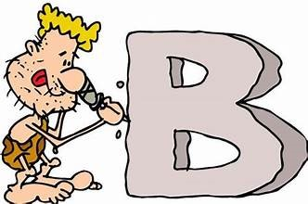
8. My best friend has a great _______________________ . (PERSON).
9. You need a lot of ______________________ to write a good story (IMAGINE)
10. The lesson was slow that I almost died of ________________________. (BORE)
11. I have to hold a __________________ at my brother’s wedding (SPEAK)
12. There’s a lot of ________________________ about that on the internet (INFORM)
13. He has to wear these gloves for _____________________ reasons (SAFE)
14. He didn’t have any ______________________ to support his opinion. (ARGUE).
15. When I was studying for exams I put on some ____________________ (WEIGH).
16. I had no _________________________ in finding the right street. (DIFFICULT)
17. Gandhi talked about __________________ and peace in our world (FREE)
18. The _____________________ of our rainforests is a serious problem (DESTROY)
19. __________________ does not have anything to do with how much money you have (HAPPY)
20. He has been a long- _______________________ runner for a few years now (DISTANT)
21. This is my last ______________________ . – Don’t walk across the lawn! (WARN)
22. He gave me some good __________________ on where to go shopping (ADVISE)
23. If you want to complain about the product, please go to the __________________ (MANAGE)
26. My mother spent her _______________________ in France (CHILD)
24. I have made a few ______________________ to your article (CORRECT)
25. Every child should get a good _________________________ (EDUCATE).
26. Listen carefully to the __________________ before you go out! (INSTRUCT)
3
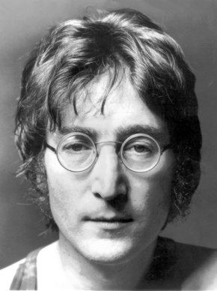
John Lennon: A True Dreamer
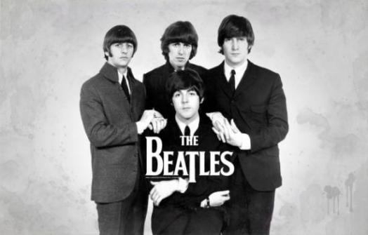
John Lennon was born on October 9, 1940, in Liverpool, England, during a German air raid in World War II. When he was 4 years old, Lennon's parents separated and he grew up with his Aunt Mimi. Lennon's father was a seaman and did not see a lot of his son when he was young. His mother, Julia, remarried but visited him regularly. She taught Lennon how to play the piano and bought him his first guitar. Unfortunately, she was fatally struck by a car in 1958. Lennon felt devastated, as his mother’s death was one of the saddest events in his life. As a child, Lennon was a prankster and he enjoyed getting into trouble. His school master advised him to go to an Art College because his grades were bad but had artistic talent.
The explosion of rock music in the 1950s inspired the 16-year-old Lennon to create a band called The Quarry Men. He soon met Paul McCartney , and the two formed one of the most successful songwriting duets in musical history. Soon, the guitarist George Harrison and the drummer Ringo Starr joined the band. They were all working-class teens. They changed their name into The Beatles, and this is how the most successful and influential band ever was formed. With John and Paul writing the songs, they started making one hit song after the other.
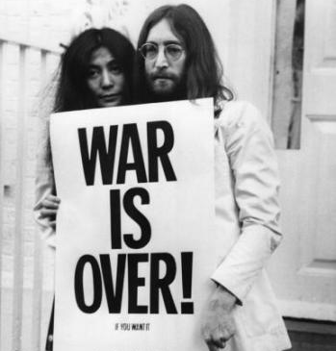
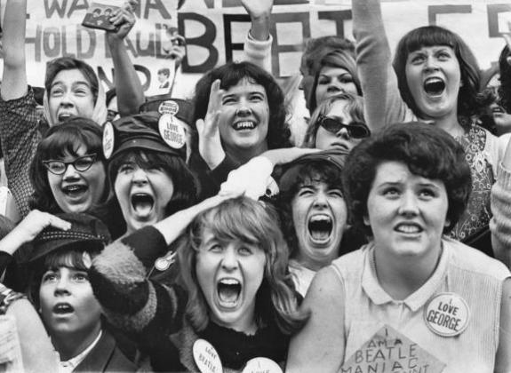
In 1962, Lennon married Cynthia Powell and had a son but they divorced in 1968. He remarried the following year, to Japanese artist Yoko Ono. The huge success of The Beatles all over the world created what was called “Beatlemania”. Girls screamed and fainted wherever they performed and boys wanted to look like them. The whole planet was crazy about The Beatles to such an extent that John Lennon said “The Beatles are even more popular than Jesus Christ!” Their album Sgt. Pepper's Lonely Hearts Club Band (1967) is the greatest project in musical history! Lennon left the Beatles in September 1969. The news of the break-up was kept secret until they released their last album Let It Be.
After that, Lennon used his popularity to promote peace in the world. Together with his second wife Yoko Ono, they organized several anti-war protests to raise people’s awareness on world peace and disarmament. His songs Imagine and Give Peace a Chance became world-famous and inspired people to ask for peace and love. In 1971 Lennon and Ono moved to the USA, but were threatened because of their activism against the unpopular Vietnam War. In 1975 his second son was born and John decided to leave the music world for a while and devote to his family.
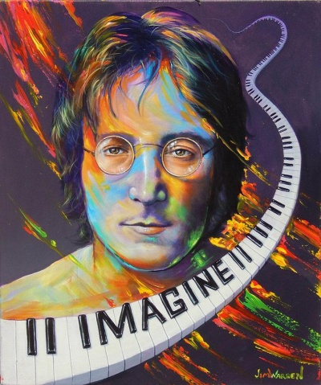
In 1980, he decided to make a comeback but just a few weeks after his album's release he was assassinated. Tragically, Mark Chapman, a mentally deranged fan, shot Lennon several times in front of his apartment complex in New York. Lennon died at New York City's Roosevelt Hospital on December 8, 1980, at the age of 40. The whole world was shocked and millions of his fans around the world gathered in public places with flowers and candles to honour him. Still today, he is considered one of the most inspiring and influential musicians of modern times and his song Imagine was voted song of the Millennium 30 years later!

4

- Decide if the statements are true or false.
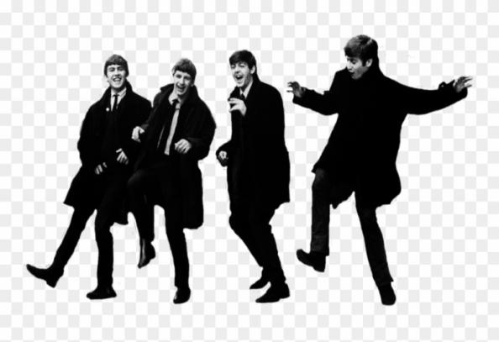
- John Lennon was born during a bombardment. T / F
- His parents broke up when he was a teenager. T / F
- His mother died in a car accident T / F
- Lennon was a good student at school. T / F
- The first name of the group was The Beatles. T / F
- Lennon got married twice. T / F
- Beatlemania was spread all over Britain. T / F
- Lennon became an activist for peace. T / F
- Lennon was shot by someone who disliked him. T / F
- Imagine was voted song of the Millenium in 2010 T / F

2. Match the correct halves

1. John Lennon was born on October 9, 1940,…  2. Lennon's parents separated and he grew up…  3. As a child, Lennon was a prankster and he…  4. They changed their name into The Beatles, and this is how…  5. The huge success of The Beatles all over the world…  6. Lennon used his popularity to promote …  7. John and Yoko organized anti-war protests…  8. John decided to leave the music world for a while…  9. Mark Chapman, a mentally deranged fan, shot Lennon…  10. Millions of his fans around the world…  11. He is considered one of the most inspiring and influential… | a. and devote to his family.  b. in front of his apartment complex in New York.  d. created what was called “Beatlemania”  d. peace in the world  e. the most successful and influential band ever was formed  f. gathered in public places with flowers and candles to honour him  g. with his Aunt Mimi  h. musicians of modern times!  i. in Liverpool, England  j. enjoyed getting into trouble  k. to raise people’s awareness on world peace and disarmament

3. Complete with the right word in bold from the text
1. Unfortunately, Nick and Vicky ……………………………… after being married for 14 years.
2. Jim is a big …………………………... He likes to play tricks on others.
3. Have you heard? There was a bomb ………………………………. at the Mall.
4. The car was damaged to such an …………………………….. that it couldn’t be repaired.
5. Advertisements are trying to ……………………………………. new products.
6. Lennon tried to raise people’s …………………………………… on world peace and unity.
7. The burglar …………………………………. the old man with a knife.
8. You need to …………………………………….. more time to studying.
9. Lennon was shot dead by a ……………………………………….. deranged fan.
10. Families usually ………………………………………………… together at Christmas.
5
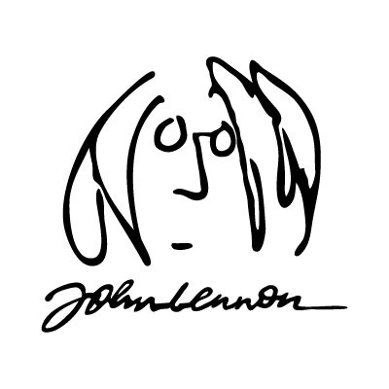
Imagine, by John Lennon
Imagine there’s no heaven, it’s easy if you try
No hell below us, above us, only sky
Imagine all the people living for today

Imagine there’s no countries, it isn’t hard to do
Nothing to kill or die for, and no [1] ____________________, too
Imagine all the people living life in [2] _____________________

You may say I’m a dreamer, but ‘m not the only one
I hope someday you’ll join us, and the world will be as one

Imagine no [3] _______________________, I wonder if you can
No need for [4] __________________ or [5] ____________________
A [6] ________________________ of man

Imagine all the people sharing all the world...

1. Listen to the song and complete gaps [1] to [6] in the lyrics above using words from the box. Then match each target word to its definition below.
possessions •greed • brotherhood • peace • hunger • religion

a. ___________________ things that belong to a person; personal property.
b. ___________________ wanting more money, power, or food than you actually need.
c. ___________________ a strong feeling of unity, friendship, and support among people.
d. ___________________ a state or period in which there is no war, conflict, or violence.
e. ___________________ a system of faith, belief, and worship.
f. ___________________ a severe lack of food; the feeling of needing food.

2. Use the words from Task 1 to rewrite the line from the song as in the example.
e.g. Imagine no possessions: Try to picture a world where nobody owns private property.
1……………………………………………………………………………………………………………………………………………………………………………………
2……………………………………………………………………………………………………………………………………………………………………………………
3……………………………………………………………………………………………………………………………………………………………………………………
4………………………………………………………………………………........................................................................................................5……………………………………………………………………………………………………………………………………………………………………………………

3. Write your own lyric beginning with “Imagine ….”
…………………………………………………………………………………………………………………………………………………………………………………………………………………………………………………………………………………………………………………………………………………………………………
6
Let’s practice: Reported Questions

2. Change the questions from DIRECT to REPORTED SPEECH:
Yes / No questions
1. She asked, “Do you live with your family, Helen?”
………………………………………………………………………………………………………………………………………………………………………..…..
2. Tom asked, “Can I borrow your pen, Linda?”
……………………………………………………………………………………………………………………………………………………………………………..
3. Phil asked me, “Does your uncle live in England?”
……………………………………………………………………………………………………………………………………………………………………………..
4. Mary asked Lucy, “Will you come to my party tomorrow?”
……………………………………………………………………………………………………………………………………………………………………………..
5. Mark asked, “Did you phone me last night, John?”
…………………………………………………………………………………………………………………………………………………………………..………..
6. Sam asked, “Is this yours or mine, David?”
……………………………………………………………………………………………………………………………………………………………………………..
7. Sara always asked me, “Must you always ask me what I’m doing?”
…………………………………………………………………………………………………………………………………………………………………….……..
8. The teacher asked, “Are you listening to me?”
……………………………………………………………………………………………………………………………………..……………………………………..
9. Mary asked, “Do you want me to help you, Larry?”
…………………………………………………………………………………………………………………………………..………………………………………..
10. The officer asked, “Are you a foreigner? Can you spell your name?”
……………………………………………………………………………………………………………………………………………………………………………..

Wh-questions
1. He asked, “How long does it take you to have lunch?”
………………………………………………………………………………………………………………………………………….………………………….……….
2. He asked me, “What are you doing at the weekend?”
…………………………………………………………………………………………………………………………..………….……………………………………….
3. The teacher asked, “Why are you late, Tom?”
………………………………………………………………………………………………………………….…………………..……………………………………….
4. My mother asked me, “Where is your umbrella?
……………………………………………………………………………………………………………………..………………………………..……………………….
5. The secretary asked the man, “Who do you want to see, sir?”
………………………………………………………………………………………………………………………………..……………………………………………….
6. The students asked, “What time does the bell ring?”
………………………………………………………………………………………………………………………………………………………………………………….
7. Larry asked Tom, “What kind of films do you like watching?”
……………………………………………………………………………………………………………………………….………………………………………………….
8. The teacher asked the girl, “When do you have to be home?”
………………………………………………………………………………………………………………………………..………………………………………..……….
9. The passengers asked, “When did the last train leave?”
………………………………………………………………………………………………………………………………………………..………………………………….
10. He asked, “What will you do tomorrow, Jane?”
……………………………………………………………………………………………………………………………………….………….……………………………….
7

Marie Curie: A Life of Science and Discovery
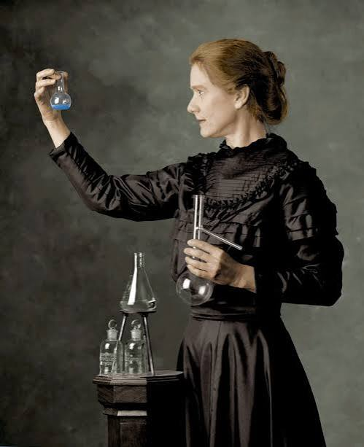
Marie Curie is one of the most famous scientists in history. Born Maria Skłodowska in Warsaw, Poland, in 1867, she showed a brilliant mind from a young age. However, during her youth, women in Poland were not allowed to go to university. Because she was determined to continue her education, Marie worked as a tutor to save money and eventually moved to Paris in 1891 to study physics and mathematics at the Sorbonne.
In Paris, life was not easy. Marie had to overcome poverty and language barriers, but her hard work paid off. Soon, she met Pierre Curie, a French scientist who shared her deep love for science. They married in 1895 and became research partners. Together, they began to conduct groundbreaking experiments on mysterious rays produced by uranium.
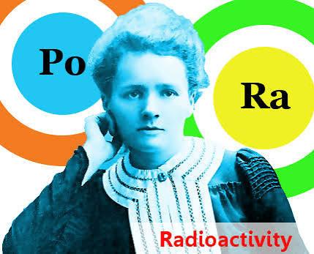
Through endless hours in their simple laboratory, the couple discovered two new chemical elements: polonium (named after Marie's homeland, Poland) and radium. Marie coined the term "radioactivity" to describe the energy released by these substances. Their remarkable discoveries changed science forever. In 1903, Marie and Pierre, along with Henri Becquerel, were awarded the Nobel Prize in Physics. Marie became the first woman ever to win a Nobel Prize.
Tragedy struck in 1906 when Pierre died in a street accident. Despite her grief, Marie continued their work alone. She became the first female professor at the University of Paris and made another huge contribution to science by isolating pure radium. In 1911, she won a second Nobel Prize, this time in Chemistry, making her the first person to win Nobel Prizes in two different scientific fields.
Marie was a true pioneer in medicine as well. During World War I, she was passionate about helping wounded soldiers. She helped create mobile X-ray units, known as "Little Curies," which allowed field doctors to locate bullets and treat broken bones on the battlefield.
Unfortunately, prolonged exposure to radioactive material severely harmed her health, as scientists at the time did not understand the dangers of radiation. Marie Curie passed away in 1934, but her inspiring legacy lives on today as a symbol of perseverance and scientific brilliance.

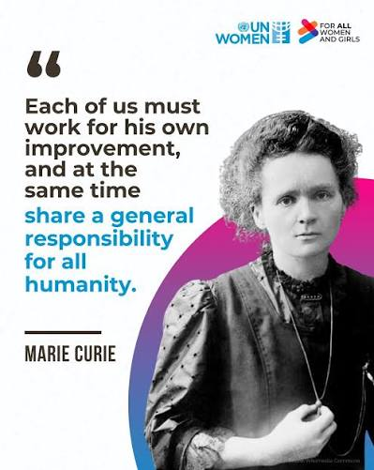
- Read the text and answer the questions
- Where was Marie Curie born, and why did she have to move to Paris to attend university?
- What difficulties did Marie experience when she first moved to France?
- What scientific process did Marie and Pierre Curie study together in their laboratory?
- What two chemical elements did the Curies discover, and how did polonium get its name?
- What milestone did Marie achieve in 1903?
- How did Marie continue her work after the tragic loss of her husband in 1906?
- How were the "Little Curies" used during World War I?
- Why did Marie Curie's work with radioactive materials eventually affect her health?
8
- Match each bolded word from the text (1–10) with its correct definition (A–J).
Word | Definition
1. determined | A. Having strong feelings or enthusiasm for something.
2. overcome | B. Something valuable that is passed down from the past or remembered after someone dies.
3. conduct | C. To successfully deal with or defeat a problem or difficulty.
4. element | D. Having a firm decision to do something and refusing to give up.
5. remarkable | E. One of the basic chemical substances (like oxygen ) that cannot be broken down simpler.
6.contribution | F. The state of being exposed to something harmful or dangerous.
7. pioneer | G. To organize and carry out a particular activity or experiment.
8. passionate | H. Worthy of attention; extraordinary or exceptional.
9. exposure | I. An action or work that helps bring about a result or helps something succeed.
10. legacy | J. A person who is among the first to explore or develop a new area of study or knowledge.
- Complete the sentences using six of the bolded words in their correct form.
- Dr. Smith plans to _____________________ a new scientific study on renewable energy next month.
- She showed a __________________ talent for solving complex mathematical equations at a very young age.
- Despite failing her first driving test, she remained ________________________ to pass on her second try.
- Wearing protective clothing reduces direct ___________________________ to dangerous chemical liquids.
- Ada Lovelace was a computer science ________________________ who wrote the very first algorithm.
- His major ___________________________ to the project helped the team finish ahead of schedule.
Reported Commands & Requests
1. Woman to the porter: “Carry my suitcases.”
……………………………………………………………………………………………………………………………………………………………………………..
2. Policeman to a suspect: “Describe your car.”
………………………………………………………………………………………………………………………………………………………………….………….
3. Mother to the boy: “Don’t hurt yourself.”
…………………………………………………………………………………………………………………………………………………………………………….
4. The robber to the man: “Give me your money.”
……………………………………………………………………………………………………………………………………………………………….…………….
5. Teacher to the student: “Show me your book.”
………………………………………………………………………………………………………………………………………………………….………………….
6. The traffic warden to us: “Don’t park here.”
…………………………………………………………………………………………………………………………………………………………..………………..
7. Woman to her husband: “Don’t forget to take your key.”
………………………………………………………………………………………………………………………………………………………..…………………..
8. Mr. Smith to her son: “Don’t use your mobile so much.”
……………………………………………………………………………………………………………………………………………………..……………………..
9. Boy to his mother: “Please mum, buy me this toy.”
……………………………………………………………………………………………………………………………………………………………………………..
10. The man to his son: “Hurry up! Don’t miss the bus!”
9

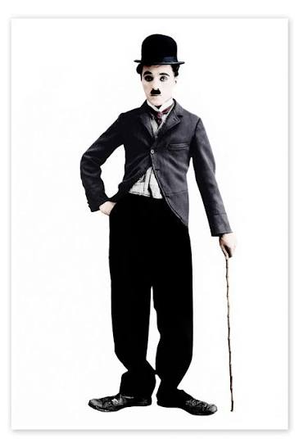
Charlie Chaplin: The Genius of Silent Cinema
Charlie Chaplin was one of the most famous actors and filmmakers in cinema history. Born in London in 1889, his childhood was marked by extreme poverty and hardship. His parents were performers, but after his father left and his mother became ill, young Charlie had to fend for himself. To earn money, he began working on stage as a child actor and dancer.
In 1913, Chaplin moved to the United States, where his career took off. Shortly after arriving in Hollywood, he created his most iconic character: "The Little Tramp". Wearing a bowler hat, baggy trousers, tight jacket, and a small mustache, this character became a global phenomenon. The Tramp was poor and often unlucky, yet he remained polite, brave, and humorous despite his struggles.
Because movies at the time were silent, Chaplin relied heavily on physical comedy and pantomime to express emotions and tell stories. He was not only a gifted actor, but also a total creative force who wrote, directed, and even composed the musical scores for his films. Works like The Kid (1921), City Lights (1931), and Modern Times (1936) blended hilarious slapstick humor with deep emotional and social critique.
When sound was introduced to movies, Chaplin was hesitant to make his characters speak, fearing it would ruin the universal appeal of his visual comedy. However, in 1940, he made The Great Dictator, a powerful political satire that openly mocked Adolf Hitler and criticized war.
Throughout his life, Chaplin received many honors, including a special Academy Award and a knighthood from the Queen of England. He passed away in Switzerland in 1977. His extraordinary contribution to cinema lives on, proving that laughter can cross all boundaries.
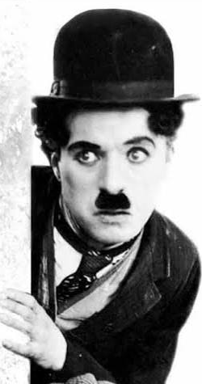
A. Read the text and decide if the statements are True (T) or False (F). Correct the false ones.
- Charlie Chaplin spent a comfortable childhood without financial difficulties.
- Chaplin started performing on stage when he was a child.
- The "Little Tramp" character was created before Chaplin moved to the United States.
- "The Little Tramp" wore a bowler hat, large pants, and a small mustache.
- Chaplin only acted in his movies and hired other people to direct and compose music.
- Silent movies required actors to use physical gestures and body language to tell stories.
- City Lights and Modern Times contained both slapstick comedy and social criticism.
- Chaplin immediately welcomed talking movies as soon as sound technology was invented.
- The Great Dictator was a film that poked fun at Adolf Hitler.
- Chaplin spent the final years of his life in Switzerland.

B. Fill in the blanks using suitable words from the text to complete this brief summary of Charlie Chaplin's life.
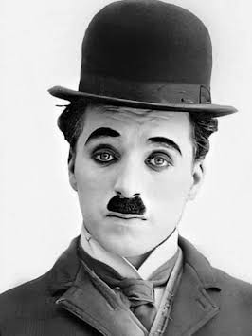
Charlie Chaplin was a famous English (1) ______________________ who gained worldwide fame during the era of (2) ________________ cinema. Despite growing up in extreme (3) ____________ in London, he developed a passion for performing on stage. After moving to the United States, he invented his most iconic character, the (4) ____________________. Chaplin wrote, directed, and created music for his own films, using (5) _________________ comedy to address real-world social problems. He remains a legendary figure in movie history.

10
C. Match each bolded word from the text (1–10) with its correct definition (A–J).
Word | Definition
1. filmmaker | A. A person who directs or produces movies.
2. hardship | B. A rounded, hard black hat worn by men in the past.
3. fend | C. To express disapproval or analyze the good and bad qualities of something.
4. bowler | D. Extreme difficulty, suffering
5. phenomenon | E. To create or write music.
6. pantomime | F. To manage or take care of oneself without help from others.
7. compose | G. Acting without words, using only body movements and facial expressions.
8. critique | H. Very unusual, remarkable, or impressive.
9. extraordinary | I. Something or someone that is extremely successful, famous, or impressive.
10. satire | J. A genre that uses humor, irony, or exaggeration to mock people's stupidity or political ideas.
D.Use the correct bolded word from the text to complete each sentence.
- After leaving his parents' house, he had to _________________ for himself by getting two part-time jobs.
- Many families in the 19th century lived in severe ____________________ due to a lack of employment.
- Mozart began to __________________ beautiful pieces of classical music when he was only five years old.
- The actor was famous for using ________________ to make audiences laugh without uttering a single word.
- The movie was a sharp political ___________________________ that made fun of corrupt politicians.
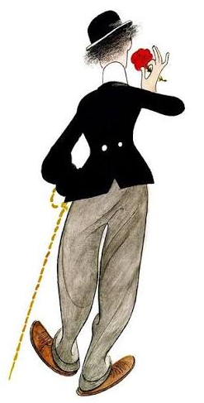
- Complete the chart by filling in the missing word forms.
Verb | Noun | Adjective | Adverb
e.g., direct | director / direction | direct | directly
1. perform | ____________ | ____________ | —
2. — | poverty | ____________ | —
3. compose | ____________ | ____________ | —
4. criticize | ____________ | ____________ | critically
5. — | ____________ | extraordinary | ____________

11
Let’s practice: Reported Speech
Change into REPORTED SPEECH. You can use AND, BUT, BECAUSE, ADD to join the sentences.
1. Brenda said to Jimmy, “Please, turn off the TV. The film is boring.”
…………………………………………………………………………………………………………………………………………………..……………………….………
2. “Wash your face and get dressed.” Bill’s mother said.
………………………………………………………………………………………………………………………………………………………………………………….…
3. “Do your homework again. There are a lot of mistakes.” the teacher said to Kate.
……………………………………………………………………………………………………………………………………………………………………….…………… “Don’t waste your time! Finish studying.” Mrs. Dawson said to Barbara.
……………………………………………………………………………………………………………………………………………………………………..….…………
5. “Brush your teeth. They look very dirty.” Mother said to Fay.
………………………………………………………………………………………………………………………………………………….…………………………………
6. “Look out! There is a truck coming.” Kevin said to his daughter.
………………………………………………………………………………………………………………………..……………………………………………….…………
7. Janet said to David, “This book looks boring. Give me another, please.”
……………………………………………………………………………………………………………………………………………………………………………………
8. Mrs. Abbot said to Jack, “Your hair is very long. Go and have a haircut.”
………………………………………………………………………………………………………………..…………………..………………………………………………
9. Mrs. Denman said to her son, “It is very hot. Don’t play in the sun.”
…………………………………………………………………………………………………………….………………………………………………………………………
10. Mr. Newman said to Nicky, “Don’t make a lot of noise. I want to listen to the news.”
………………………………………………………………………………………………….…………………………………………………………….……………………
11. “Don’t turn it up. I have a headache.” Mother said to us.
…………………………………………………………………………………………………….………………………….……………………………………………………
12. “What have you cooked? I feel very hungry.” Tony said to his mother.
…………………………………………………………………………………………………………………………………………………………….………………………
13. Terry said to Ashley, “Don’t speak German. Speak English. They can’t understand you.”
………………………………………………………………………………………….…………………………………………………….……………………………………
14. “Please, be quiet! The baby is sleeping.” Mrs. Newton said to the children.
…………………………………………………………………………………………………………………………………………………………………………….……
15. “Will you please move aside? I can’t watch television.” John said to his brother.
……………………………………………………………………………………………………………………………………………………………………..……………
16. Mark said to us, “I want to buy a new car. Ours is very old and spends a lot of petrol.”
…………………………………………………………………………………………………………………………………………………………………………………
17. Tom said to Carol, “Can I borrow your dictionary. Mine is at home.”
…………………………………………………………………………………………………………………………………………………..………….…………………
18. “Your hands are very dirty. Go to the bathroom and wash them.” Mother said to Nicole.
………………………………………………………………………………………………………………………………………………………………………..………
19. Sandy said to Danny, “Does your mother work? I see her on the bus every day.”
…………………………………………………………………………………………………………………………………………………………………………………
20. Tom said to Jane, “I’m bored. Can we go to the cinema?”
…………………………………………………………………………………………………………………………………………………………………………………
21. Sam said to Kate, “I’m broke. Can you lend me some money?”
…………………………………………………………………………………………………………………………………………………………………………………
22. Mother said to her son, “Your friends are playing in the garden. Don’t you want to play with them?”
…………………………………………………………………………………………………………………………………………………………………………………
23. Jim said to his son, “When will you go? You are very late for school.”
………………………………………………………………………………………………………………………………………………………………….…… 12
UNIT 2: BEING CONNECTED

The Connected World: How the Internet Reshaped Our Lives
Imagine a world without smartphones, instantaneous search engines, or social media. Just thirty years ago, this was daily reality. To find information for a school project, you could not simply type a query into a search engine. You had to navigate to a physical library, search through catalog cards, and read heavy encyclopedias. Communication was equally slow. If you wanted to talk to a friend who lived far away, you wrote a letter on paper and waited days—sometimes weeks—for a reply. Entertainment was limited to scheduled television broadcasts, radio, or local video rental stores.

The arrival of the internet changed everything, completely transforming how we live, learn, and interact. Today, information is available in seconds, making research faster and education far more accessible. We can collaborate with classmates on digital projects in real time, stream music or video on demand, and maintain friendships with people across the globe through instant messaging.
However, this digital revolution is a double-edged sword. On the positive side, it has made communication effortless and enhanced our ability to acquire new skills independently. You can learn a language, master coding, or explore distant cultures without leaving your bedroom.
On the flip side, the net presents serious challenges. Spending hours online can lead to a sedentary lifestyle, reducing physical activity and face-to-face interaction. The constant exposure to notifications creates a strong distraction, making it harder to focus on studies or deep work. Furthermore, the web can be a source of misinformation, cyberbullying, and privacy risks, which can negatively impact mental health if not managed carefully.
Ultimately, the internet is a powerful tool. It has broken down geographical barriers and changed human history forever. Whether it improves our lives or disrupts them depends entirely on how responsibly we choose to navigate our digital world.

A. Read the text and answer the questions
- How did people do research for school projects before the internet existed?
- What was the main method of long-distance communication in the past?
- Mention two positive educational or social advantages of the internet described in the text.
- What does the article mean when it describes the internet as a "double-edged sword"?
- Name two negative consequences of spending too much time online.
- According to the conclusion, what determines whether the internet has a positive or negative impact on our lives?
B .Complete the sentences using the correct bolded word from the text.
- Sitting in front of a computer screen all day can lead to an unhealthy, _____________________ lifestyle.
- Learning how to search for reliable websites helps students ______________________ the web safely.
- High-speed internet connection has significantly _______________________ our ability to study online.
- Smartphone notifications can become a major ________________ when you are trying to study for an exam.
- Freedom on the web is a ______________ weapon; it offers vast knowledge but also contains potential risks.
- Public libraries make books and computer equipment __________________ to everyone in the community.
- Students from different countries can easily ___________________ on shared research projects using online document tools.
- I typed a quick _______________________ into the search bar, but the website didn't bring up any results.
- Social media apps make it easier to __________________ friendships with old classmates who moved away.
- Screen time must be carefully _______________ so that it does not interfere with sleep and physical health. 13

Let’s Practice: Tech Vocab
A. Match the technology phrases on the left (1–8) with their correct definitions on the right (A–H).
Phrase | Definition
1. digital footprint | A. To move text or images up or down on a screen to see more content.
2. cyberbullying | B. To save a website address in your browser so you can return to it easily.
3. at the click of a mouse | C. To enter your username and password to start using a website or account.
4. go viral | D. The trail of data you leave behind whenever you use the internet.
5. scroll through | E. To spend time looking at different websites online without a specific plan.
6. bookmark a page | F. Very quickly and easily, without needing to make much effort.
7. surf the net | G. Sending harmful or threatening messages to someone online.
8. log in | H. To become extremely popular on social media in a very short time.
B.Complete the sentences below using the correct phrase from the box. Change the verb forms (e.g., past tense or -ing form) where necessary.
1.Be careful about what you post on public forums; everything you share contributes to your overall ____________.
2.Yesterday, I spent two hours just _______________________ when I was supposed to be studying for my exams!
3.Modern shopping apps allow you to buy almost anything ________________________.
4.The funny video of the cat playing the piano got millions of views in just 24 hours and __________________.
5.I was late submitting my assignment because I couldn't ____________________ to the school portal due to a password error.
6.If you find a recipe you like on that blog, you should _________________ so we can make it again next week.
7.Schools are holding workshops to teach teenagers how to report cases of online harassment and ______________.
8.She was casually ____________________ her social media feed when she noticed an announcement for her favorite band's new tour.

B.Choose the correct word (A or B) to complete each sentence.
1) My phone's operating system took 20 minutes to _______ last night to fix a few security bugs.
A) upgrade B) update
2)You need to enter your parent's email to gain _______ to the restricted gaming server.
A) access B) excess
3.)The developer tried to _______ that their app had a security flaw, claiming the reports were completely false.
A) refuse B) deny
4)Smart home gadgets can control almost every electrical _______ in your house, from the toaster to the AC unit.
A) appliance B) device
5)Heavy phone usage right before bed can negatively _______ your sleep quality.
A) affect B) effect
6)I decided to _______ my old laptop for a much faster model with a faster processor and double the RAM.
A) update B) upgrade
7)The app asked permission to use my camera, but I decided to _______ because I didn't think it was necessary.
A) refuse B) deny
8)Doctors warn that an _______ of screen time can lead to severe eye strain and headaches.
A) access B) excess
9)A portable smartwatch is a versatile _______ that can track your heart rate, steps, and incoming messages.
A) appliance B) device
10)Scientists are studying the long-term _______ of artificial intelligence on future job markets.
A) affect B) effect 14


Let’s Watch: How life will look like in 2050
Watch the following video that predicts what life will look like in 2050.
https://www.youtube.com/watch?v=6_q_LHq85Cs
1. After you watch talk about one advance you remember for each of the fields: Nanotechnology, 3D print, medical, transport, space, AI, money and housing.
2. Watch again and complete the sentences with the missing word.
NANOTECHNOLOGY
1. Nanotechnology has the ………………………………. to change life as we know it.
2. Nanobots will be fitted in our ………………………… to connect us to the virtual world more readily and faster.
3. With nanotechnology there will be no need for …………………………….. like phones and calculators.
3D PRINT TECHNOLOGY
4. In the future, we‘ll be able to print more ……………………………… and perhaps even some modes of transportation.
5. If the current trend of Open Source 3D printable files continues, it won’t be long before everyone prints their own large objects like …………………………………… or weapons.
6. The development of an affordable 3D printer for food could be the end of world ……………. despite global warming.
MEDICAL
7. The information stored in our brains will be transferred into a hard disc and then …………………………….. into a robot.
8. Serious ……………………………….. like cancer will be cured.
9. The only downside is that every new technology is very …………………………………. when it first comes out.
TRANSPORTATION
10. By 2050, the technology for fully automated …………………………………. will exist.
11. A notable advantage will be a drastic ………………………………….. in traffic-related deaths.
FUEL
12. The fuel used in all future transportation modes will be ……………………………….. energy.
13. Hopefully, Blue Rise and their …………………………………… will be successful soon enough to alleviate some of the environmental problems we face.
SPACE EXPLORATION
14. Space exploration will help people to live on other ……………………………….. with colonies.
15. Unfortunately, a space trip will be significantly expensive, making it an exclusive trip for the extremely ……………….
ARTIFICIAL INTELLIGENCE
16. AI experts believe that AI will surpass the processing power of living …………………………...
17. The rise of AI will change the face of workforce, as half of the world’s current jobs will be ………………………., taken over by AI machines and robots.
EDUCATION
18. By 2050, completely ………………………………. schools will be commonplace.
19. Even if there are physically attended schools, they will have no need for ………… using tablets and laptops instead.
METAVERSE
20. The metaverse is a virtual reality computer-generated ………………………………. in which you can interact with users through AI enabled software.
21. It seems that the more we are …………………………………, the more we stay apart.
MONEY
22. It seems that ……………………………………….. will no longer be used in 2050.
23. Our refridgerators will ……………………………….. our groceries.
REAL ESTATE
24. Homes of the 2050 will be completely ………………………………………..
25. Smart homes in the 2050 will have full AI activation functions, allowing the home to sense our moods and requirements without giving it a single ……………………………………..

26. There will be no need to look for the remote control again because you can control the TV with your ………… using nanotechnology. 15

Let’s Practise: Passive Voice
1. Fill in the PASSIVE in the appropriate tense:
1. (TV / invent / Baird) …….. TV was invented by Baird. ………………………………………………………………...
2. (Pyramids / build / Egyptians) …………………………………………………………………………………………………….
3. (milk / produce / cows) ……………………………………………………………………………..……………………………….
4. (coffee / grow / in Brazil) ……………………………………………………………………………………………………………
5. (chopsticks / use / in China) …………………………………………………………………………..……………………………
6. (plants / water / every day) …………………………………………………………………………….…………………………..
7. (the thief / arrest / yesterday) ……………………………………………..……………………………………………………..
8. (the injured man / take to a hospital / now) ………………………………………………………………………………..
9. (the car / repair / tomorrow) ………………………………………………………………………………….……………………
10. (the letter / send / last week) …………………………………………………………………………………..…………………
2. Turn from ACTIVE into PASSIVE:
1. The gardener has planted some trees.
…. Some trees have been planted by the gardener..
2. Doctor Brown will give you some advice.
……………………………………………………………………………………………………………………….…………………………………
3. A famous designer will redecorate the hotel.
……………………………………………………………………………………….…………………….……………………………………………
4. Steven Spielberg directed “E.T.”
……………………………………………………………………………………………………………………………………………………………
5. Someone has broken the crystal vase.
……………………………………………………………………………………………………………………..……………………………………
6. His parents have brought him up to be polite.
…………………………………………………………………………………………………………………………….……………………………
7. Fleming discovered penicillin.
…………………………………………………………………………………………………………………..………………………………………
8. They will advertise the product on television.
………………………………………………………………………………………………………………….…………………………………………
9. Someone is remaking that film.
………………………………………………………………………………………………………………………………..……………………………
10. Picasso painted that picture.
………………………………………………………………………………………………………………………………………………………………
3. Using the PASSIVE, ask questions to which the bold type words are answers:
1. Columbus discovered America. …….. Who was America discovered by………… ?
2. We keep money in a safe. ……………………………………………………………………….……………………………………… ?
3. A bee stung him. ………………………………………………………………………………………………………………………………?
4. They speak Italian in Italy. ……………………………………………………………………..………………………………………… ?
5. They have taken his aunt to hospital. ………………………………………………….……………………………………………?
6. The boys damaged the television. ……………………………………………………………..…………………………………….. ?
7. Da Vinci painted the Mona Lisa. ……………………………………………………………………………………………………….. ?
8. He invited 30 people to his party. ……………………………………………………………..…………………………………….. ?
9. They grow bananas in Africa. …………………………………………………………………………….…………………………….. ?
4. Turn from ACTIVE into PASSIVE:
1. You must leave the bathroom tidy. …….. The bathroom must be left tidy. ………..
2. You should water this plant daily. …………………………………………………………………………..…………………….. 16
3. Our neighbor ought to paint the garage. ……………………………………………………………………………………………………….
4. I have to return these books to the library. ……………………………………………………….……..…..………………………………
5. You must dry-clean this shirt. ……………………………………………………………………….……………………..……………………….
7. Someone will pay you in ten days. …………………………………………………………………………………..……………………………
8. You can improve your health with more exercise.……………………………..…………………..……………………………………..
9. People must obey the law. ………………………………………………………………………………………………….……………………….
5. Turn from ACTIVE into PASSIVE:
1. Someone is helping her with the housework.
…………………………………………………………………………………………………………………………………………………………………….………..
2. A pickpocket robbed me.
…………………………………………………………………………………………………………………………………………………..………………………….
3. The mail-order company sent Mrs. Green a parcel.
………………………………………………………………………………………………………………………………………………….…………………………….
4. A dog is chasing the child.
……………………………………………………………………………………………………………………………………………………..………………………….
5. My friend sent me an invitation.
…………………………………………………………………………………………………………………………………………………….…………………………….
6. The farmer is building a new barn.
……………………………………………………………………………………………………………………………………………….………………………………….
7. The secretary has given Mrs. Jones some letters.
…………………………………………………………………………………………………………………………………………………….…………………………….
8. The traffic warden had already given him a ticket for illegal parking.
……………………………………………………………………………………………………………………………………………….…………………………………….
9. Someone had broken our door down.
……………………………………………………………………………………………………………………………………………..………………………………………
10. They chose him as the best actor of the year.
……………………………………………………………………………………………………………………………………………………………………………..………

6. Turn form ACTIVE into PASSIVE as in the example:
1. He gave me a present.
a) I was given a present.
b) A present was given to me.
2. The waiter will bring us the bill.
a) …………………………………………………………………………………………………………………………………..……………………………
b) …………………………………………………………………………………………………………………………….……………………………………
3. The Queen presented him with a medal.
a) …………………………………………………………………………………………………………………………………………………………………
b) ………………………………………………………………………………………………………………………………………………………………….
4. Her mother bought Mary some sweets.
a) …………………………………………………………………………………………………………………………………………………………………..
b) ………………………………………………………………………………………………………………………………………………………………..
5. Bob has sold Ted a second-hand car.
a) …………………………………………………………………………………………………………………………………………………………………
b) …………………………………………………………………………………………………………………………………………………………………
6. Larry is going to send a letter to Tom.
a) ………………………………………………………………………………………………………………………………………………………………
b) …………………………………………………………………………………………………………………………………………………………………
17
7. Put the following sentences into the PASSIVE VOICE:
1. Someone has already paid the electrician for his work.
………………………………………………………………………………………………………………………………………………………………...
2. They taught him French and gave him a dictionary.
………………………………………………………………………………………………………………………………………………………………....
3. When we first met, they had already offered me a job at the bank.
…………………………………………………………………………………………………………………………………………………………………...
4. A man requested the stranger to leave the meeting.
……………………………………………………………………………………………………………………………………………………………………
5. A young woman asked the rest of us to be there at eight o’clock.
…………………………………………………………………………………………………………………………………………………………………..
6. They had eaten all the dinner before they finished the conversation.
…………………………………………………………………………………………………………………………………………………………………….
7. Who wrote it?
……………………………………………………………………………………………………………………………………………………………………..
8. The author has written a special edition for children.
…………………………………………………………………………………………………………………………………………………………………….
9. Did the idea interest you?
……………………………………………………………………………………………………………………………………………………………………
10. Why didn’t they mend the roof before it fell in?
…………………………………………………………………………………………………………………………………………………………………….
11. The burglars had cut a huge hole in the steel door.
……………………………………………………………………………………………………………………………………………………………………..
12. The organizers will exhibit the paintings till the end of the month.
………………………………………………………………………………………………………………………………………………………………………
13. When did they ring the church bells?
………………………………………………………………………………………………………………………………………………………………………
14. Does listening to music disturb you?
………………………………………………………………………………………………………………………………………………………………………

8. Write the correct passive tense.

Hospitals are places where people ……………………………………. (examine) and ……………………………… (bring) back to good health. I’m lucky because I ………………… ……………….……………(never / take) to hospital but my sister …………………………… (hit) by a car last year. Luckily, no bones …………………………….…….. (break) but she ……………………………………… (examine) carefully and x-rays …………………………….……………… (take). She ………….……………….. (keep) there for a night and she ………………………………….. (give) permission to leave the next day.
Ambulance services are also important. Patients …………………….………… (must / take) to hospital as quickly as possible. A lot of people ………………………………… (kill) in road accidents and a lot more ……………………………………. (injure) but if more ambulances …………………………………. (put) into service, more lives

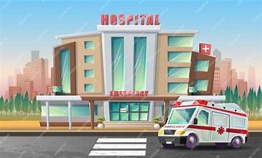

18
Let’s Read: SMART PHONES
The smart phone is state-of-the-art appliance / device and is regarded as a practical, convenient and necessary communication tool of modern social life. The development of technology for smart phones modernized / outdated communications. It has paved the way / road for SMS, text messages, calls, video chat, and applications that allow individuals to connect with others around the world instantly.
Why is a smart phone useful?
- You can carry your smart phone wherever you go and use it in case of urgency / emergency. Lots of human lives have been saved thanks to smart phones.
- Smart phones can give us some easy / comfortable fun when we want to relax. You can watch funny videos, listen to music or play your favourite games. Also, texting is free and offers you a fun way to interact / contact with others.
- You can go online anytime anywhere and download all sorts of songs and games to / on your smart phone. What’s more, you can take, store and send photos and videos in a split second / moment.
Are people victims of their mobile phones?
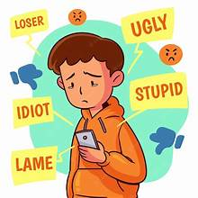
- Lots of people consider mobile phones to be an explosion / invasion to their privacy. Mobile phones have cameras and so our private life may be videoed and be used for cyber-bullying or even blackmailing. Text bullying has become another serious social problem especially among teenagers.
- Scientists warn that smart phones are a serious hazard / warning to our health. They can cause eye-strains, headaches and even harm / injure our brains and cause brain tumors.
- Absorbing games and social media that are available on smart phones can contribute / include to addiction even for kids under the age of ten.
- They can be a public nuisance / problem. People, especially teenagers, keep using their mobile phones in public places without showing any respect for others.
- The can cause distraction. Texting messages and watching videos all the time distracts students of / from their schoolwork. Even worse, they are accused / blamed for distracting drivers and causing accidents.
Smart phones are here to stay and move forwards. It’s up to us to consider their careful use.


- In what ways have smart phones modernized communications?
- How can smart phones be helpful in case of emergencies? Give some examples.
- What kind of easy fun can smart phones offer you?
- What kind of things can online connection to smart phones allow you to do?
- In what ways are smart phones an invasion to privacy?
- How do smart phones threaten our health?
- Why may smart phones cause disturbance?
- What are the results of distraction for students and drivers?
A.Complete the sentences below using the target words and collocations in the box. Use each item only once.
blamed for • harm • in a split second • interact • modernized • privacy
1)Social media platforms allow teenagers to ____________________ with friends across the globe in real time.
2)The rapid evolution of mobile technology has completely ____________________ how businesses communicate.
3)High-speed internet allows photos to be sent to another device ____________________.
4)Distracted driving is often ____________________ causing major traffic accidents on highway roads.
5)Posting personal photographs online without permission can violate someone’s right to ____________________.
6)Looking at bright screens in the dark for hours can ________________ your eyesight and cause severe headaches.
B.Circle or underline the correct preposition or word to complete each standard phrase.
- High levels of device usage can contribute (to / with) screen addiction in young children.
- Studying with a smartphone on your desk can distract you (of / from) focusing on your homework.
- You should keep emergency numbers saved (on / at) your mobile phone at all times.
- Smart devices are considered a major health hazard (for / to) people who do not take regular breaks. 19

Let’s Read and write a story


The Unplugged Morning
Leo woke up at 7:00 AM, but his smart alarm had failed to ring. He reached for his phone on the nightstand to scroll through his notifications, but the screen stayed pitch black. He pressed the power button repeatedly—nothing happened.
Confused, Leo walked into the living room. His mother was tapping her tablet with a look of frustration. "The internet is completely down," she said. "In fact, every device in the neighborhood seems broken."
Leo ran outside. His friends were standing in the street, staring blankly at their dead smartphones. There was no social media, no online gaming, and no way to send a quick text. At first, panic set in. How would he stay in touch with anyone?
However, as the hours passed, something strange happened. Without notifications constantly demanding his attention, the neighborhood began to change. Since nobody could surf the net, kids started gathering in the local park. Someone brought a real football, and an intense match broke out. Later, Leo spent two hours reading a fantasy novel he had bought months ago but never opened. He didn't have to worry about his digital footprint or whether a video would go viral.
By the evening, Leo realized he hadn't felt this relaxed in years. He sat on his porch, listening to the birds, feeling genuinely connected to the real world around him.
Suddenly, a loud, buzzing noise shattered the peace. Leo opened his eyes. He was in his bed, hugging his pillow, while his phone alarm played its usual annoying tune on the nightstand. The screen lit up with dozens of unread messages and notifications. He took a deep breath, smiled, and turned the phone face down. It had only been a dream, but he decided today would be different anyway.
Read the statements below and decide whether they are True (T) or False (F) according to the story.
- Leo woke up late because his phone alarm did not work. ( T / F )
- Only Leo’s house lost power and internet access. ( T / F )
- The teenagers in the neighborhood panicked at first when their devices stopped working. ( T / F )
- Leo played an online multiplayer football game with his friends in the afternoon. ( T / F )
- By the end of the day, Leo felt stressed because he missed his notifications. ( T / F )
- When Leo woke up in real life, he immediately started reading all his unread messages. ( T / F )

Let’s Write: "A World without Technology"
Write a short story (120–150 words) about a day when technology suddenly stops working.
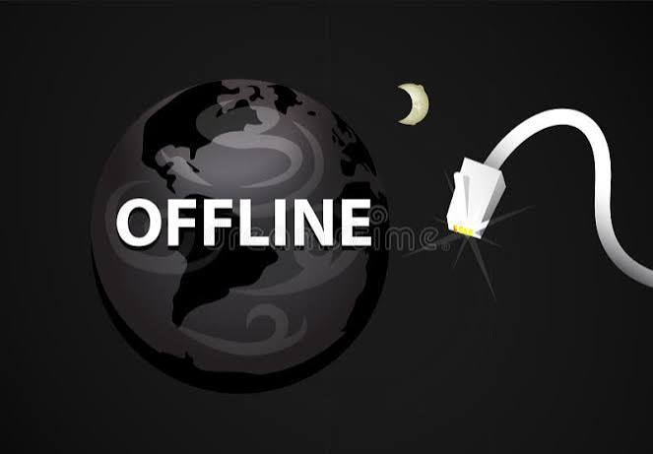
Follow this 3-part plan to structure your story:

1. The Shock (Beginning)
- How did you realize technology is broken? (e.g., your phone won't turn on, the Wi-Fi disappears, your smart watch dies).
- How did you feel in the first 5 minutes?

2. The Solution (Middle)
- What did you decide to do instead of using screen time?
- What surprise or positive experience happened in the real world?

3. The Twist (Ending)
- Did you wake up from a dream, or did the power suddenly return?
- How did you feel at the end?
20
UNIT 3: SHOP TILL YOU DROP!

Shopping Mania
It is said that shopping is therapy / treatment. It has the power / strength to help people get rid of any negative thoughts, even for a small / short time. Most people support that shopping gives them a sense of satisfaction, either when they shop sensibly / irrationally or even if they exceed their bargain / budget. Therefore, shopping has become a pleasant pursuit and shopping mania an addiction / extinction.
Apart from the conventional way of shopping, online shopping and telemarketing are winning / gaining ground. This means that they are both on / in the increase, because people in their effort to save time and avoid rushing and queuing into shops they prefer to shop at the pleasure / comfort of their own homes. Therefore, the manufacturer’s aim is to devise the most attractive advertising techniques on the Internet to progress / promote their products and draw the consumer’s attention. As a result, Internet advertising and online shopping has become a thriving / rich business for many companies today. They even use brainwashing to persuade consumers to buy and make them obsessed with shopping. However, there are misleading / false advertisements, too and consumers must know and demand their goals / rights when they are deceived or misinformed.

Brand Name Mania
Do you know what a large number of people and especially teenagers frantically buy today? Brand-name products of course! It’s a recent trend / event which encourages teens to buy designer clothes or accessories. Social media has made them become appearance-conscious and believe that appearance is what makes a good impression / expression on others. If they are dressed in fashion, they may feel self-confident and trendy and give them a sense of belonging to a group. Yet, such labels are overpriced and cost a good deal / amount of money.
In any case, when you go on shopping spree / adventure, try to spend your money wisely and handle it well.

A.Read the text and decide if the statements are True or False
1) According to the text, shopping therapy can eliminate negative thoughts permanently.
2) People can feel a sense of satisfaction from shopping even when they spend more money than they planned.
3) Online shopping and telemarketing are becoming less popular over time.
4) Consumers choose to shop from home primarily to save time and avoid standing in lines.
5) Social media plays a major role in making teenagers more concerned about their outward appearance.
6) Wearing trendy designer clothes can give teenagers a feeling of confidence and group acceptance.
7) The text notes that brand-name products are usually affordable and reasonably priced.
B. Fill in the blanks using the correct words from the box below.
amount • budget • ground • impression • misleading • spree • therapy • thriving
1} After a stressful week at work, Sarah went to the mall for some retail ____________________.
2) Online shopping platforms are gaining ____________________ as more people prefer buying goods from home.
3) If you do not stick to your monthly ____________________, you might end up running out of money before payday.
4) The company ran a ____________________ advertisement that gave customers incorrect information about the product's price.
5) Wearing neat, formal clothes to a job interview helps you make a positive ____________________.
6) Digital marketing has become a ____________________ business that generates billions of dollars worldwide.
7) He spent a massive ____________________ of money on that new designer watch.
8) They decided to go on a weekend shopping ____________________ and bought clothes from every store in town.

C. Choose the Correct Preposition or Phrase
- Telemarketing is (on / in) the increase because more consumers prefer shopping at home.
- During the holidays, many people prefer to buy gifts at the comfort (of / from) their own houses.
- Consumers should always know their legal rights when they are deceived (by / with) false advertising.
- Teenagers often feel a sense of belonging (to / with) a peer group when they follow popular trends. 21
Let’s Practice: Money & Shopping Vocabulary

1. Shopping Phrasal Verbs: Choose the right option.
1. Good morning! Is it OK if I look round / look out for your shop?
2. Can you lend me some money? I’ll pay you back / pay you off next week.
3. The clothes shop at the corner doesn’t have any customers. I think it will shut over / shut down.
4. I love the pattern on this dress. I’ll try it out / try it on.
5. A fashion victim always wants to keep up with / keep down with the latest fashions.
6. Meg was put away / put off by the price of the computer, so she didn’t buy it
7. I need to save up for / save on a new pair of shoes, so I'm not buying coffee this month.
8. I don't need any help, thanks! I'm just browsing through / checking out these t-shirts.

2. Fill in with the correct preposition ( in / on / by / of ) and then complete the sentences 1-7
a. …………. the sales b. ……………. offer c. …………… debt d. ……………… fashion
e. …………. an advert f. free ……… charge g. …………… cash h. ……………… credit card
1. Fay saw this cool watch …………………………………………..……………. on TV.
2. If you don’t stop spending so much money, you’ll soon be …………………………….……………………… .
3. I want to get a pair of new trainers …………………………..………………………… but they won’t start till January.
4. It’s not always safe to pay …………………………………………………….. when you shop online.
5. Sally is very stylish, she only wears clothes and footwear that are ……………………………………………………… .
6. I had lots of money with me, so I decided to pay ………………………..………………………….. .
7. All the sports equipment is …………………………………………………… this week. Tennis rackets are only 20 €!
8. We can send you your purchases without extra cost. Shipping is …………………..……………………………… .

3. Complete with the right word.
1. uniform / costume
- Tony has a great …………………………………… for the fancy dress party. He’s hired a police …………………………………
borrow / lend
- I’ll ……………………………….. you my earphones as long as you let me …………………………. your blue jacket.
bargain / purchase
- Her latest …………………………….. was a new handbag. She said it was a ……………………………… at 100€.
convenient / comfortable
- Sue doesn’t feel ………………………………….….. in tight clothes at work. She finds loose shirts and trousers more ………………………………………….. .
return / refund
- Any ………………………………. is accepted as long as you have the receipt with you. And of course, if any goods are faulty, you’ll get a ……………………………………… .

fake / artificial
- No one could tell that the lake wasn’t natural but …………………………………………
- The thief was wearing a ………………………..…………… beard in order not to be recognized.
valuable / priceless / worthless
- Mum has a lot of …………………………………… jewellery.
- There are numerous ………………………………….. paintings at the museum.
- The ring is ………………………………….. but it has sentimental value to me.
alive / living
- The market was ……………………………………….. with traders and customers.
- He earns his …………………………………………….. by working as a market trader.
22

Let’s Practice: Word Building / Making Adjectives
1. Thanks so much for the gift. It was very ___________________ of you. (THOUGHT)
2. The weather was _________________ but we didn’t let it spoil our holiday. (MISERY)
3. Sue was very ______________________ to me through my hard times. (SUPPORT)
4. Ella had a very good sleep last night so she feels much more ______________________ today. (ENERGY)
5. _____________________ studies have shown that reading can significantly reduce stress. (SCIENCE)
6. She was very __________________ and hoped to become a lawyer before she reached the age of 35. (AMBITION)
7. Thank you for everything you’ve done. You’ve been very ______________________________ (HELP).
8. Buying a late night flight ticket is usually more ___________________________ . (ECONOMY)
9. The ___________________________ situation of the country is terrible. (ECONOMY)
10. Keith often turns up late to meetings. He is quite ______________________ . (RELY)
11. Texting on your phone while driving is __________________________. (RESPONSE)
12. I do not think it is a good idea to go to the beach today. It’s too ___________________________ (CLOUD).
13. The police are looking into the _________________________ disappearance of the old man (MYSTERY)
14. Don’t touch that snake. It’s extremely ____________________________ (POISON).
15.I think it’s a very _____________________ thing to wait before you buy the house. Prices might go down (SENSE)
16. Who prepared this fish? It’s awful and completely ____________________________ (TASTE).
17. There are so many interesting things to see in the city. The list is _________________________ . (END)
18. The new Mercedes is quite _____________________________. I don’t think we can afford it. (COST)
19. It is quite ____________________________ that there are other living beings in the universe (BELIEVE).
20. It’s _____________________________ that Phil wants to recover after the accident. (UNDERSTAND)
21. A phrasebook is a very _______________________ thing to have when you visit a foreign country (USE).
22. The film had such a __________________________ ending that moved the audience to tears. (DRAMA)
23. How ________________________ of you to bring flowers! (THOUGHT)
24. Climate change is a ____________________________ problem. (UNIVERSE)
25. It was a ______________________ action to save the old lady from the burning building. (HERO)
Make groups of four. Note down the most common adjective endings and try to find two similar words for each case. The group who finds them first is the winner.
NEGATIVE PREFIXES
MOST COMMON →un- or in- / dis-: unbelievable / incomplete / disrespectful
l → il: illogical m →immature r → ir: irreparable p→ im: impossible
Fill in with the correct prefix to form opposites.
1 ____comfortable 2 ____patient 3 ____honest 4 ____ lucky 5 ____formal 6 mature ____
7 ____possible 8 ____legible 9 ____ moral 10 ____responsible 11 ____legal 12 ____polite
13 ____familiar 14 ____logical 15 ____convenient 16 ____relevant 17 ______ dependent
18 ____accurate 19 _____organised 20 _____ conscious 21_____personal 22 ____obedient
23 ____literate 24_____helpful 25 ____perfect 26 _____mortal 27 _____healthy
23


Don’t Get Fooled!

The Hidden Tricks of Advertising
Have you ever bought something online, opened the package, and instantly regretted it? You are not alone. Every day, every average consumer is target-practiced by clever marketing teams. Companies spend billions studying human psychology just to figure out how to push us into making an impulse purchase.
To grab your attention, brands use sneaky “tricks of the trade.” One classic method is creating a false sense of urgency. When you see a banner shouting "Limited Time Offer!" or "Only 2 items left in stock!", it triggers a fear of missing out. You feel pressured to rush to the checkout before thinking twice. Another common tactic is clever pricing. Items priced at $19.99 feel significantly cheaper than $20, even though the difference is a single penny.
However, some strategies go too far and become outright misleading advertising. Fast-food commercials are infamous for this trick. That juicy, towering brand-name burger on TV? Food stylists often use cardboard spacers to add height, engine oil instead of syrup, and glue to make milk look thick and fresh. What you see in the ad is almost never what you get at the counter.
Technological shifts have made ads even more personal. Online retailers track your browsing history to deliver targeted ads straight to your social media feed. They highlight glowing reviews—sometimes written by paid influencers—to build trust. They offer a limited-time discount or a bundle deal to convince you that you are securing a massive bargain.
Before you know it, you are handing over your hard-earned money for items you never needed. Smart shoppers know how to spot these psychological traps. Next time you feel the urge to buy, pause and ask yourself: Do I really need this, or is a clever ad controlling my choices?

Read the text and decide if the following statements are True or False
- The article suggests that companies spend very little money studying consumer behavior. ( T / F )
- Pricing an item at $19.99 is a psychological trick to make it seem noticeably cheaper. ( T / F )
- Fast-food ads frequently use real, edible food ingredients to prepare burgers for photo shoots. ( T / F )
- Online stores use your browsing history to show you personalized advertisements. ( T / F )
- All online product reviews are guaranteed to be authentic and unpaid. ( T / F )
- The main purpose of the text is to help readers become more aware of advertising tactics. ( T / F )

Match the bolded words with their definition.
Word | Definition
1. Consumer | A. A person who buys goods or services for personal use.
2. Purchase | B. The place where you pay for goods in a store or website.
3. Checkout | C. An official name or symbol given to a product by a company.
4. Brand | D. The act of buying something, or the item that was bought.
5. Reviews | E. A reduction in the usual price of something.
6. Discount | F. Something bought for a lower price than usual.
7. Bargain | G. Written opinions where people judge the quality of a product.
  - Complete the summary using the correct bolded words
Advertisers use psychological tricks to convince every 1. ___________ to spend money. They use tactics like artificial urgency, strategic pricing, and misleading photos to encourage a fast 2. ____________. Online stores track your activity to promote their 3. __________ through targeted ads and special offers. By offering a sudden 4. _________, companies make you believe you are getting an incredible 5. ____________, even if you do not need the item. 24
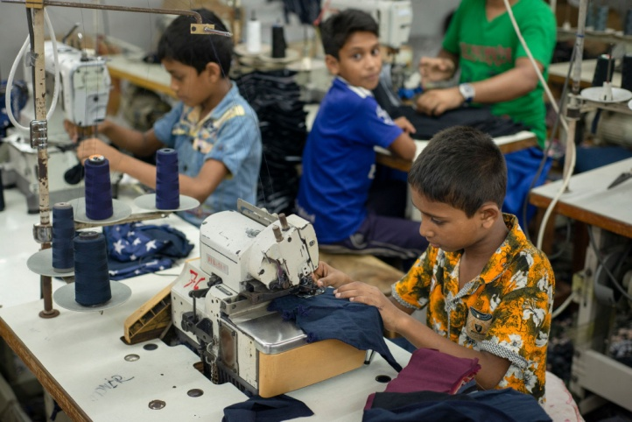
The True Cost of Fashion
-Child Labour in Global Supply Chains-
When you buy a brand-name hoodie or a sleek pair of sneakers, you pay a high price for quality and status. But have you ever wondered who actually makes these luxury items? Deep within complex global supply chains across parts of Asia and Africa, millions of young teenagers work under terrible conditions to produce goods for wealthy global markets.
Instead of going to school, these children spend twelve to fourteen hours a day in dark garment factories, dangerous cocoa plantations, or dusty mines. They endure severe exploitation by factory managers who take advantage of their young age and vulnerability. Because these children come from families struggling with extreme poverty, they are forced to sacrifice their education to help their parents survive.
What makes this reality truly shocking is the extreme unfairness of the system. Big corporations make massive profit by selling these items in Western stores for hundreds of dollars. Yet, the children who stitch the fabric or harvest the raw materials receive a tiny wage—often just a few cents a day. This creates huge inequality between the massive fortunes earned by fashion executives and the desperate lives of the child workers who make their products possible.
Furthermore, many young laborers face physical abuse when they fail to meet strict daily quotas or make small mistakes. They carry out dangerous tasks without safety gear, ruining their health before they even reach adulthood.
Human rights organizations are urging consumers to demand transparency from multinational brands. By raising awareness, supporting fair-trade initiatives, and rejecting unethical companies, we can help break the cycle of human misery and ensure that every child gets the education and protection they deserve.
Adapted from Save the Children.com

A.Read the text and decide if the questions are True or False
1)Child labor is mostly used to produce cheap, low-quality local goods rather than expensive global brand-name products. ( T / F )
2) Children involved in labor in Asia and Africa often work 12 to 14 hours a day instead of attending school. ( T / F )
3)Corporations share a large percentage of their profits with the child workers who manufacture their goods. ( T / F )
4)Extreme poverty is one of the main reasons children are forced to work. ( T / F )
5)Working conditions in these factories and mines are generally safe and well-regulated for young teenagers. ( T / F )
6)Human rights groups encourage consumers to hold international brands accountable for their supply chains. ( T / F

B. Complete the sentences using the eight bolded words from the text:
- Many families live in severe _________________ and cannot afford basic necessities like food or medicine.
- The company made a huge ____________________ of millions of dollars after selling their new collection.
- Workers in developing countries often earn a microscopic daily _____________ for long hours of hard labor.
- Child labor compared with the huge corporation profits prove the __________________ of the system.
- The unfair treatment and physical ____________ inflicted by supervisors created an environment of fear.
- The extreme income _________________ between corporate executives and factory workers is alarming.
- Companies that take advantage of vulnerable workers are guilty of workplace ___________________.

- Ending child labor is essential to free millions of young children from lives of hopeless ________________
C.Complete the summary using the correct bolded words from the list below:
Millions of children in Asia and Africa suffer from extreme 1. ____________, forcing them to work long hours in hazardous conditions. Brand-name companies earn huge amounts of 2. ____________ by selling products made by these children for high prices. However, the young workers receive an unfair, tiny 3. ____________ that barely keeps them fed. This cruel form of 4. ____________ highlights the growing global 5. ____________ between wealthy consumers and underpaid child laborers.

25
Let’s watch: The world’s largest shopping malls.
https://www.youtube.com/watch?v=anV8utiTQrk
Watch the video. Which of these malls would you like to visit? Why?
Watch again. Complete the missing words.
1.In the SIAM PARAGON you can watch a film at the state-of-the-art cinema ……………………………, see marine life in an Ocean aquarium, watch an opera performance at the concert hall, play bowling in the bowling alley or sing along at the ……………………………………karaoke centre.
2. In BERJAYA TIMES SQUARE in Malaysia you can go shopping in 1,000 retail shops, choose to eat at 65 food ………………………………………. or entertain yourself at a massive indoor theme park.
3. ISTANBUL KEVAHR has a spacious stage for hosting various events, a ………………………….. cinemas, a bowling alley, a miniature roller coaster and numerous other ……………………………………… options.
4. MEGAMALL in the Phillipines has an ice-skating ………………………………. and numerous cinemas .
5. WEST EDMONTON MALL in Canada is a miniature city, as under one ……………………………you can find a water park, a marine life ……………………………………….. and even a replica of Christopher Columbus’s Santa Maria.
6. In DUBAI MALL you can find over 1,200 shops, including the largest ………………………... shop in the world, an ice rink, a Sega game centre with a captivating 3D bowling game, a ……………………………………. 5 star hotel, as well as 22 cinema screens and an impressive selection of 120 restaurants and cafes.
7. The SM MALL OF ASIA in the Philippines is a place where shopping meets ………………………………………….
8. CENTRAL WORLD in Bankgong is not only about size, it’s a …………………………………… experience where you can find everything from high-end fashion labels to quirky local boutiques.
9. The GOLDEN RESOURCES MALL in Beijing, China hosts over ……………………………………….. stores that cater to every imaginable taste.
10. The IRAN MALL offers a unique tour of Persian culture and global influences all under one roof that really transforms the shopping experience to an ……………………………………………. of exploration and joy.
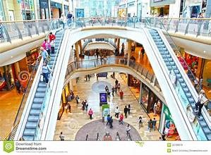
26
Let’s Write: Online Shopping vs. Shopping at the Mall

A. Read the 12 clues below (6 for Online Shopping, 5 for Mall Shopping). Sort each clue into the correct box .

- Clue A: You can try on clothes immediately to see if they fit properly.
- Clue B: You have to pay extra shipping fees and wait several days for delivery.
- Clue C: You can shop 24/7 from the comfort of your own couch.
- Clue D: You can enjoy a fun social day out with your friends and grab food at the food court.
- Clue E: You cannot physically inspect or touch the product quality before buying.
- Clue F: Parking can be difficult, and stores are often overcrowded and noisy.
- Clue G: Returning items by post can be complicated, slow, and frustrating.
- Clue H: It is very easy to compare prices across dozens of different websites in seconds.
- Clue I: You have access to a huge variety of international brands and rare products.
- Clue K: You have to carry heavy shopping bags around all day long.
- Clue L: You get personal help and advice directly from helpful shop assistants.
Shopping Type | Positive Aspects (Pros) | Negative Aspects (Cons)
Online Shopping | 1.  2.  3. | 1.  2.  3.
Shopping at the Mall | 1.  2.  3. | 1.  2.

B.Now that you have looked at both sides, answer these 3 quick questions to build your outline:
- Which type of shopping do you prefer overall?
  - My Choice: __________________________________________________
- What are your top 2 reasons for choosing it? (Pick 2 positive clues from Step 1)
  - Reason 1: __________________________________________________
  - Reason 2: __________________________________________________
- What is 1 main disadvantage of your chosen shopping type, and how do you deal with it?
  - Disadvantage: __________________________________________________
  - How I deal with it: ___________________________________________

C.Use the clues to write an essay of about 150 words on the topic. Do you prefer shopping online or at a mall?
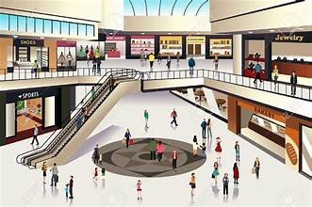
- Paragraph 1 (Introduction): Hook the reader + state your preference (Online or Mall).
- Paragraph 2 (Body 1): Present your two main reasons (Pros of your choice).
- Paragraph 3 (Body 2): Mention one counter-argument (Con of your choice) and why it doesn't stop you from preferring it.
- Paragraph 4 (Conclusion): Summarize your main points and restate your final opinion.
27
UNIT 4: THE SILVER SCREEN

THE WORLD OF CINEMA

Look at the posters and decide what film genres they are. What other film genres do you know?

Which are your favourites?

Romantic Comedy Horror Action Crime Fantasy
A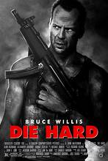 B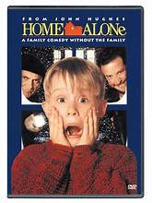 C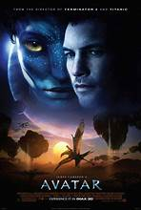 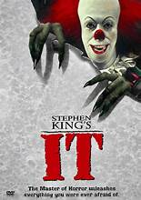 E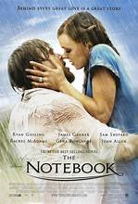 F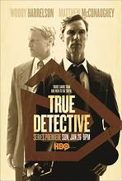
A.Match the vocabulary words in Column A with their correct definitions in Column B.
Column A (Words) | Column B (Definitions)
1. Genre | a. the written text of a movie, including the dialogue and stage directions.
2. Blockbuster | b. the group of actors who perform in a movie.
3. Director | c. a category or style of movie (e.g., sci-fi, comedy, horror, documentary).
4. Script | d. computer-generated visuals or audio created to simulate imaginary events.
5. Cast | e. A movie, book, or play that continues the story of a previous one.
6. Protagonist | f. An article or essay giving an opinion on how good or bad a movie is.
7. Sequel | g. A hugely popular movie that achieves massive commercial success.
8. Soundtrack | h. The main character or central figure in a story or movie.
9. Special effects | i. The music created for or used in a movie.
10. Review | j. The person who controls a movie's artistic and dramatic aspects and guides the crew and actors.
B.Complete the passage below using the ten words above. Change word forms if necessary.
Going to the cinema is one of the world's most popular forms of entertainment. Whether you prefer a heart-pounding action movie or a spooky horror film, every (1) _______________ offers something unique. Before a movie ever reaches the big screen, a writer must craft the (2) _________________, laying out the dialogue and story. Next, the (3) _______________ takes charge on set, guiding the (4) _______________ of actors to bring those lines to life.
To make modern movies even more exciting, studios often rely on impressive (5) _____________________ to create realistic explosions, alien worlds, or mythical creatures. Music also plays a key role—a memorable (6) ____________ can make an emotional scene unforgettable.
When a movie centered around a compelling main (7) _______________ becomes a huge hit at the box office, it is celebrated as a (8) _____________________. If it makes enough money, the studio will almost certainly produce a (9) _______________ a few years later to continue the story. Finally, before deciding whether to buy a ticket, many moviegoers read an online (10) _______________ to see what critics thought.

28

Decide which film kind the passages are about

WE LOVE MOVIES!

1.……………………………………………….

They are spine-chilling stories that aim to scaring the audiences to death. They are always about serial killers or monsters, vampires and zombies. The fans of the kind love these movies because they keep them at the edge of their seats.

2…………………………………………………..

American directors love making these films. The protagonist is a detective or person trying to solve a murder mystery and searches for clues to find the villain. They are full of suspense and usually become blockbusters, bringing in millions of dollars.

3………………………………………
They are love stories with two protagonists that fall in love. The lovers usually have to go through difficulties, such as accidents, illnesses or deaths. Most of the times, the script has a happy ending. They usually have nice soundtracks, which people love to sing or dance.

4……………………………………………………..

They are adventure films with a lot of fighting, car crashes and destruction scenes. They are full of amazing stunts, which are thrilling to watch.

5……………………………………….
They are very entertaining. The main characters get into funny or humorous situations. Good ones have excellent acting and a clever plot.

6...………………………………………

In these films star magical creatures that do not exist in the real world. Some stories take place in a real-world setting but others create imaginary worlds with their own laws and logic. They usually have amazing special effects.

Explain the words in bold. Then, choose the right option.
1)The “Titanic” was one of the biggest blockbusters / special effects ever, bringing in millions of dollars.

2)Johny Depp stars / stunts in the “Pirates of the Caribbean” as a scary but funny pirate.
3)The horror film was full of blockbuster / spine-chilling scenes that kept viewers on the edge of their seats.
4)Joker is a typical villain / director who gets caught in the end.
5)Actors should be well-prepared to have excellent script / acting in the film they play.
6)The best scene / script of the film was when the detective caught the serial killer.
7)The blockbuster / soundtrack of the film is such a success! Everyone sings it!
8)The crime story was so full of acting / suspense that I couldn’t get my eyes off the screen!
9)One of the most impressive soundtracks / stunts in the film was when the protagonist jumped off the Eiffel Tower.
10)The film had such an interesting suspense / plot that kept me stuck on the screen.
11)Most Hollywood directors / blockbusters love making crime movies.
12)If the film has a good script / villain with a gripping story, it can become a box office hit.
13)The directors / special effects were so amazing that I thought I was really in a fantasy world.
29
MEDIATION-GROUP WORK
Make 6 groups of 4 students. Choose a film and read the information about it in Greek. Then, prepare a presentation of the film in English. Use the words and phrases from pages 28-29. Then, present the film to your classmates. Write about:
What kind of film is it?
When did it come out?
Who is it directed by?
Who stars in it?
Write a few words about the plot.
What are the strong points of the film?
What are the weak points of the film?
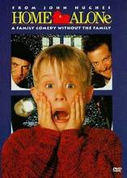
HΟΜΕ ALONE 1 - 1991
Μια αμερικάνικη οικογένεια πρόκειται να ταξιδέψει στο Παρίσι για τις διακοπές των Χριστουγέννων. Tην ημέρα της αναχώρησης έχoυν υπερβολικό άγχος με αποτέλεσμα να ξεχάσουν πίσω τον 8χρονο Κέβιν. Ο Κέβιν βρίσκεται ξαφνικά ολομόναχος στο σπίτι, και έρχεται αντιμέτωπος με δύο διαρρήκτες. Όμως, χάρη στο θάρρος και τη φαντασία του, καταφέρνει να τους αντιμετωπίσει…
Σκηνοθεσία: Chris Columbus
Κύριοι Ρόλοι: Macaulay Culkin : Kevin , Joe Pesci : Harry, Daniel Stern: Marv
Catherine O’Hara : Kate McCallister
ΣΥΝ και ΠΛΗΝ: Καθόλου τυχαία πρόκειται για μία από τις πιο αγαπημένες χριστουγεννιάτικες ταινίες όλων των εποχών. Ο τρομερός Μακόλεϊ Κάλκιν ξεχωρίζει με την εκπληκτική ηθοποιία του. Το ίδιο και οι δύο κλέφτες. Η ταινία υπήρξε μεγάλη επιτυχία φέρνοντας 500 εκατομμύρια δολάρια στα ταμεία . Το όμορφο μουσικό θέμα της ήταν υποψήφιο για Όσκαρ. (Filmy.gr)

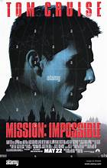
MISSION IMPOSSIBLE 1- 1996
Σκηνοθεσία: Brian De Palma
Κύριοι Ρόλοι: Tom Cruise : Ethan Hunt, Emmanuelle Beart :Claire Phelps
Jon Voight: Jim Phelps
Μια ομάδα μυστικών πρακτόρων προσπαθεί να εμποδίσει έναν ξένο πράκτορα από το να ανακαλύψει και να πουλήσει μια μυστική λίστα κατασκόπων. Ωστόσο, κάποιος τους έχει στήσει παγίδα, και όλοι πεθαίνουν εκτός από τον Ίθαν Χάντ και μια κοπέλα. Ενώνοντας τις δυνάμεις τους, φτιάχνουν μια νέα ομάδα και προσπαθούν να πάρουν τη λίστα, και συγχρόνως να ανακαλύψουν ποιος τους πρόδωσε. Η περιπέτεια ξεκινάει και όλοι μπλέκονται σε ένα ατελείωτο παιχνίδι ζωής και θανάτου.
ΣΥΝ και ΠΛΗΝ:Mια ταινία δράσης που έγινε μεγάλη επιτυχία. Η πλοκή είναι ενδιαφέρουσα, όμως σε κάποια σημεία μπερδεύει.
Στα συν της ταινίας τα ειδικά εφέ και οι ηθοποιίες. Ο Τομ Κρουζ είναι σαφώς πολύ καλός και στις σκηνές δράσης. Κρίμα που το σενάριο είναι τόσο μπερδεμένο! (Filmy.gr)

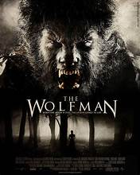
WOLFMAN- 2025
Σκηνοθεσία: Leigh Whannell
Κύριοι Ρόλοι: Christopher Abbott: Blake Lovell, Julia Garner: Charlotte Lovell, Matilda Firth: Ginger Lovell
Ο Μπλέικ με τη γυναίκα του Σάρλοτ και τη νεαρή τους κόρη Τζίντζερ επισκέφτονται το απομονωμένο σπίτι τους στο Όρεγκον. Όμως, καθώς η οικογένεια πλησιάζει την αγροικία μέσα στη νύχτα, ένα αόρατο ζώο τους επιτίθεται, και προσπαθώντας απεγνωσμένα να ξεφύγουν, κλείνονται μέσα στο σπίτι. Όσο προχωράει η νύχτα, όμως, ο Μπλέικ αρχίζει να συμπεριφέρεται παράξενα και να μεταμορφώνεται σε κάτι τρομακτικό.
ΣΥΝ και ΠΛΗΝ:Η ταινία τρόμου απευθύνεται κυρίως σε έφηβους, που λατρεύουν το είδος. Στα συν της ταινίας τα ειδικά εφέ και η ανατριχιαστική μουσική που δημιουργεί αγωνία και κατατρομάζει τους θεατές! Αρκετά καλές και οι ηθοποιίες. Παρ’ όλα αυτά, η ταινία θυμίζει πολλές προηγούμενες ταινίες του είδους και στηρίζεται πιο πολύ στη δράση παρά στην πλοκή. (Filmy.gr)
30
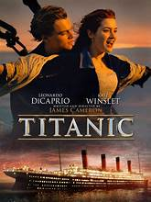
TITANIC-1997
Σκηνοθεσία: James Cameron
Κύριοι Ρόλοι: Leonardo DiCaprio : Jack Dawson, Kate Winslet: Rose Dewitt Bukater
84 χρόνια μετά το ιστορικό ναυάγιο, η εκατοντάχρονη Ρόουζ διηγείται τη συγκλονιστική ιστορία που ξεκίνησε στις 10 Απριλίου 1912, όταν επιβιβάστηκε στον Τιτανικό μαζί με τους υπόλοιπους επιβάτες της πρώτης θέσης, τη μητέρα της και τον αρραβωνιαστικό της. Καθώς εκείνη επιβιβάζεται, ο Τζακ, ένας νεαρός καλλιτέχνης, κερδίζει στα χαρτιά ένα εισιτήριο τρίτης θέσης. Οι ζωές τους συναντιούνται πάνω στο πλοίο που θα βυθιστεί κι ένας παθιασμένος έρωτας γεννιέται.
ΣΥΝ και ΠΛΗΝ:O σκηνοθέτης Τζέιμς Κάμερον δημιουργεί μια από τις πιο διάσημες εμπορικές ταινίες όλων των εποχών. Μέσα στο θρυλικό υπερωκεάνιο που βυθίστηκε στο πρώτο του ταξίδι βλέπουμε το ρομάντζο μεταξύ ενός πλούσιου κοριτσιού και ενός φτωχού καλλιτέχνη. Στα υπέρ της ταινίας τα ειδικά εφέ, οι εξαιρετικές ηθοποιίες και το καλό σενάριο. Επίσης ,η μουσική και το τραγούδι “My heart will go on” με την Celine Dion. (Filmy.gr)

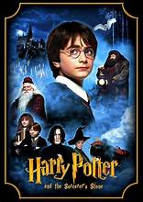
HARRY POTTER AND THE SORCERER’S STONE-2001
Σκηνοθεσία: Chris Columbus
Κύριοι Ρόλοι: Daniel Radcliffe:Harry Potter, Emma Watson :Hermione Granger, Rupert Grint : Ron Weasley
Ο Χάρι Πότερ είναι ένα εντεκάχρονο ορφανό αγόρι. Μετά το θάνατο των γονιών του ζει με τον θείο Βέρνον και τη θεία Πετούνια, που δεν τον συμπαθούν ιδιαίτερα. Στα γενέθλια του Χάρι όμως, μια κουκουβάγια του φέρνει ένα μυστηριώδες γράμμα. Κάθε μέρα μια κουκουβάγια καταφθάνει στο σπίτι των Ντάρσλι μ’ ένα νέο γράμμα. Μια μέρα τους επισκέπτεται ένας γίγαντας με το όνομα Χάγκριντ, που θα αποκαλύψει ένα απίστευτο μυστικό: ο Χάρι Πότερ είναι μάγος!
ΣΥΝ και ΠΛΗΝ: Ένας ολόκληρος φανταστικός κόσμος με τους δικούς του νόμους και λογική πρωταγωνιστεί σε μία από τις εμπορικότερες ταινίες των καιρών μας. Οι ηθοποιίες είναι εξαιρετικές, , τα ειδικά εφέ φανταστικά και το μουσικό θέμα υπέροχο. Βέβαια, το σενάριο είναι λίγο αδύναμο, αλλά μην ξεχνάμε ότι μιλάμε για ταινία φαντασίας που είναι ένα παραμύθι. (Filmy.gr)

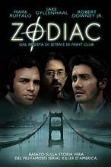
ZODIAC-2007
Σκηνοθεσία: David Fincher
Κύριοι Ρόλοι: Jake Gyllenhaal:Robert Graysmith, Mark Ruffalo : επιθεωρητής David Toschi, Robert Downey Jr.: Paul Avery
Στην Καλιφόρνια του 1968, ένας ψυχοπαθής δολοφόνος, που αυτοονομάζεται Ζόντιακ, σκορπίζει τον τρόμο. Ο περιβόητος ντετέκτιβ Ντέιβιντ Τότσι θα αναλάβει την υπόθεση, αλλά όσο κι αν βρίσκει στοιχεία για την ταυτότητα του εγκληματία, τόσο περισσότερο ο δολοφόνος τον μπερδεύει.
ΣΥΝ και ΠΛΗΝ: Το Zodiac είναι ένα καλοφτιαγμένο αστυνομικό θρίλερ που σε καθηλώνει.
Οι ηθοποιίες είναι πολύ καλές και οι ρυθμοί της ταινίας είναι γρήγοροι και κρατάνε τους θεατές σε αγωνία.
Από την άλλη είναι πολύ μεγάλη σε διάρκεια, και έχει υπερβολικά πολλές σκηνές με κυνηγητά αυτοκινήτων και καταστροφές.
(Filmy.gr)

31

Let’s Practice: Tricky Distinctions

A.Study the following groups. What are the similarities or differences among the words or phrases?
same / similar / alike
  - A: My jacket is similar to yours, but mine has a black zipper.
  - B: Sarah and her sister look so alike that people think they are twins.
  - C: We bought the same shirt from the shop; they are identical!
likely / unlikely
  - A: With these heavy dark clouds, it is likely to rain soon.
  - B: It is highly unlikely that he will win the lottery with just one ticket.
hardly any / almost no
  - A: There were hardly any people at the party when we arrived at 8 PM.
  - B: The fridge is empty—there is almost no food left for dinner.
except for / apart from
  - A: Everyone passed the exam except for Tom, who was ill.
  - B: Apart from playing the guitar, she also writes her own songs.
at the beginning / in the beginning
  - A: At the beginning of the film, the main character moves to London.
  - B: In the beginning, I found learning French difficult, but later it got easier.
at the end / in the end
  - A: Put your signature at the end of the page.
  - B: We argued for hours, but in the end, we decided to stay home.
on time / in time
  - A: The 9:00 AM train left right on time.
  - B: Hurry up! We need to get to the cinema in time to catch the trailers.
B.Circle or underline the correct option to complete each sentence based on the rules above.
- Their voices sound very (similar / same) over the phone, so I never know who is speaking.
- Please make sure you submit your homework (on time / in time) before the deadline on Friday.
- (At the beginning / In the beginning), I didn't like coffee, but now I drink two cups every morning!
- It is very (likely / unlikely) that school will be canceled tomorrow; the storm isn't severe enough.
- The detective spent months investigating the crime, and (at the end / in the end), he caught the thief.
- There was (hardly / almost)any traffic on the road today, so we arrived twenty minutes earlier.
- I love all winter sports, (except / apart) from skiing, which I find too dangerous.
- Look! We bought the exact (similar / same / alike) shoes!
C.Fill in the blanks using the terms in the box below. Use each phrase only once.
apart from • at the end • in time • likely • alike • hardly any • in the beginning


When our team started working on the school project, we faced a lot of trouble. (1) _______________, nobody could agree on an idea, and we had made (2) _______________ progress after two full days. To make matters worse, two of our group members think so (3) _______________ that they kept repeating the exact same arguments!
(4) _______________ a brief outline written by Maya, we had nothing prepared. Our teacher warned us that it was (5) _______________ we would fail if we didn't hurry up. Fortunately, we managed to organize our thoughts and finished everything (6) _______________ to submit it before midnight.
(7) _______________ of the week, our project received the highest score in class!

32

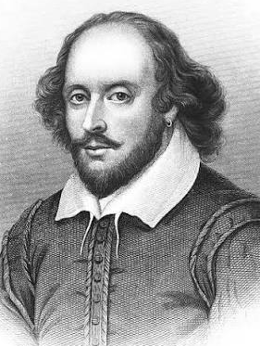
Let’s Read: Why Shakespeare Still Matters
William Shakespeare (1564–1616) was an English poet, playwright, and actor, often called England’s national poet or simply "The Bard." Born in Stratford-upon-Avon, he later moved to London, where he co-owned an acting company and wrote 38 plays and over 150 poems, becoming the most famous writer in the English language.
More than four hundred years after his death, William Shakespeare remains the world’s most celebrated playwright. You might wonder why teenagers in 2026 are still reading stories written in Elizabethan English. The answer is simple: Shakespeare understood human nature better than almost anyone else, and his influence on modern entertainment is everywhere—from Hollywood movies to hit TV series.
Shakespeare wrote for the stage, creating timeless stories about love, revenge, ambition, and friendship. His plays were performed in open-air venues like the famous Globe theatre, where audiences of all social classes gathered to watch. To bring his complex characters to life, he relied on a talented cast of actors who had to project their voices without modern microphones.
One reason his work endures is his incredible scriptwriting. Shakespeare invented over 1,700 words and phrases that we still use today. Furthermore, his dramatic structure was revolutionary. He mastered both hilarious comedies and heartbreaking tragedies, balancing intense emotion with witty dialogue.
Long before modern cinema, Shakespeare was the ultimate storyteller. Every act of his plays was crafted to keep audiences on the edge of their seats, leading up to a powerful climax that resolved the drama. Today, whether you are watching a traditional live performance or a film adaptation, Shakespeare’s themes continue to mirror our own lives.
One of his most famous plays is Romeo & Juliet. Set in the Italian city of Verona, Romeo and Juliet tells the story of two teenagers who fall deeply in love at first sight. However, their romance is forbidden because their families—the Montagues and the Capulets—are locked in an ancient, violent feud. Desperate to be together, the young lovers make a secret plan to escape the conflict. But as misunderstandings multiply and family tensions boil over, their risky scheme puts everything on the line...
Choose the correct option (A, B, C, or D).
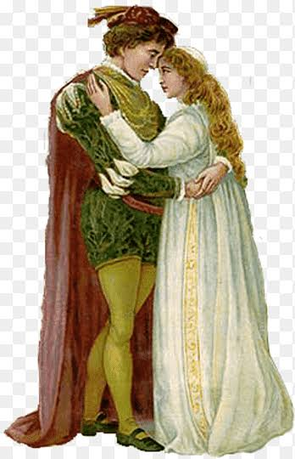
1. Why is Shakespeare still considered relevant today?
- A) He invented the first modern microphone.
- B) His stories explore timeless human emotions and themes.
- C) He only wrote stories for wealthy nobility.
- D) He was the first person to make Hollywood movies.
2. Where were many of Shakespeare's plays originally performed?
- A) In private indoor bedrooms.
- B) On television broadcasts.
- C) In open-air venues like the Globe Theatre.
- D) In local school classrooms.
3. What was remarkable about Shakespeare's writing?
- A) He invented over 1,700 words and phrases.
- B) He never wrote any tragic stories.
- C) He used simple modern slang.
- D) He wrote all his plays in one single day.
4. What is the main conflict in Romeo and Juliet?
- A) The lovers dislike each other at first.
- B) A war between two rival cities.
- C) A bitter feud between their two families.
- D) A fight over who will rule Verona.
5. How does the summary of Romeo and Juliet end?
- A) It reveals how both characters die.
- B) It explains that they move to London.
- C) It leaves the outcome open without giving away the ending.
- D) It states that their families became best friends immediately. 33
Let’s Watch: Romeo & Juliet

Pre-Watching Quiz: Franco Zeffirelli's Romeo & Juliet (1968)

Before pressing PLAY, test what you know about Shakespeare's classic love story and this legendary film

1. How old was Juliet in Shakespeare's original story?
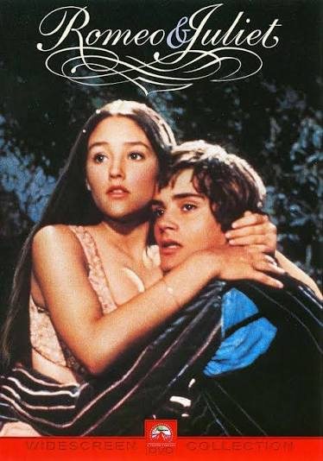
- A) 13 years old
- B) 16 years old
- C) 18 years old

2. Why was director Franco Zeffirelli's 1968 casting choice revolutionary?
- A) He hired famous Hollywood superstars.
- B) He cast actual teenagers to play Romeo and Juliet.
- C) He used animated characters instead of real actors.

3. Where in Italy is the story of Romeo and Juliet set?
- A) Rome
- B) Venice
- C) Verona

4. What starts the feud between the Capulets and the Montagues?
- A) A argument over land and money.
- B) An ancient conflict, though nobody remembers the original cause.
- C) A stolen royal crown.

5. In the movie, how can you easily tell the two rival families apart during party scenes and street fights?
- A) By the color of their costumes (Warm reds/oranges vs. Cool blues/yellows).
- B) One family wears masks, the other does not.
- C) One family carries swords, the other only carries knives.

Study the relatioships between the characters

PRINCE ESCALUS OF VERONA (Lawmaker & Ruler of Verona. Attempts to keep peace between:
┌──────────────────────────────┴──────────────────────────────
▼ ▼
┌─── ───────────────────────┐ ┌──────────────────────────┐
│ HOUSE OF MONTAGUE │ ◄─── ANCIENT FEUD ───► │ HOUSE OF CAPULET │
│ (Cooler Tones / Blues) │ "Two households..." │ (Warm Tones / Reds/Gold) │
└────────────┬─────────────┘ └────────────┬─────────────┘
┌─────────┴─────────┐ ┌─────────┴─────────┐
│ │ │ │
▼ ▼ ▼ ▼
Lord & Lady BENVOLIO Lord & Lady TYBALT
Montague (Romeo's cousin; Capulet ( Juliet's fiery,
(Romeo's parents) peacemaker) (Juliet's parents) hot-headed cousin)
▼ ▼ │
ROMEO ═════════════════════ SECRET MARRIAGE ═══════════════ JULIET │
(17 years old) (Aided by Friar) (13/15 years old)
▼ ▼ ▼
MERCUTIO NURSE
(Romeo's witty best friend; (Juliet's loyal, motherly
kinsman to Prince Escalus) servant & confidante)

34

Romeo & Juliet: Complete Plot True/False Guide

Section 1: The Street Fight & The Ball (Act 1)
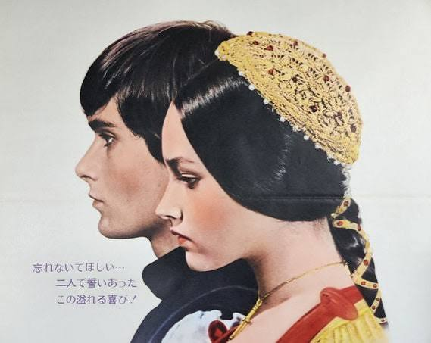
- [ ] The film opens with a peaceful market scene before a fight breaks out between Montague and Capulet servants.
- [ ] Prince Escalus warns both families that anyone who starts another street fight will be executed.
- [ ] At the beginning of the movie, Romeo is crying and depressed because he is in love with Juliet.
- [ ] Benvolio tries to keep the peace during the street brawl, but Tybalt wants to fight.
- [ ] Lord Capulet hosts a masked ball where Romeo and his friends sneak in uninvited.
- [ ] Tybalt recognizes Romeo at the ball by his voice and wants to kill him immediately.
- [ ] Lord Capulet gets furious at Tybalt and orders him to leave Romeo alone during the party.
- [ ] Romeo and Juliet fall in love at first sight before knowing each other’s family names.
- [ ] Juliet’s Nurse tells Romeo that Juliet is a Capulet.
- [ ] Juliet is happy when she discovers Romeo is a Montague because she loves rivalries.

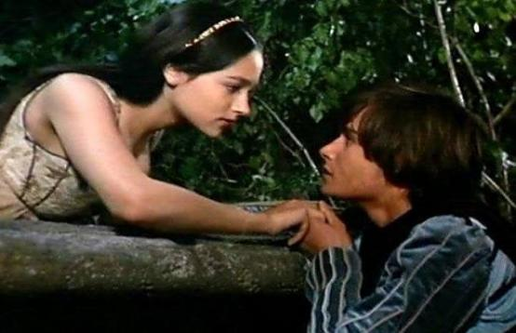
Section 2: The Balcony Scene & Secret Wedding (Act 2)
- [ ] After the party, Romeo climbs over the Capulet orchard wall to see Juliet.
- [ ] Juliet knows Romeo is hiding in the garden while she speaks about her love for him on the balcony.
- [ ] Juliet agrees to marry Romeo after knowing him for only one night.
- [ ] Friar Laurence is gathering medicinal plants and herbs when Romeo visits him early in the morning.
- [ ] Friar Laurence agrees to marry the young couple because he thinks it will end the feud between their families.
- [ ] Mercutio and Benvolio make fun of the Nurse when she comes to deliver a message to Romeo.
- [ ] The Nurse warns Romeo not to double-cross or hurt Juliet.
- [ ] Juliet waits impatiently for three hours for the Nurse to return with news from Romeo.
- [ ] Romeo and Juliet are married in secret by Friar Laurence in his cell.
- [ ] Lord and Lady Capulet attend the secret wedding ceremony.

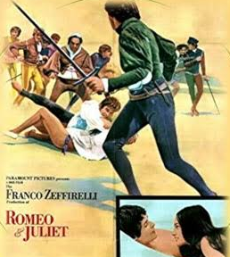
Section 3: The Tragedy in the Square (Act 3, Scene 1)
- [ ] Tybalt comes looking for Romeo in the public square to challenge him to a duel.
- [ ] Romeo eagerly fights Tybalt because he hates the Capulet family.
- [ ] Mercutio steps in to fight Tybalt because he feels Romeo’s refusal to fight is dishonorable.
- [ ] Tybalt stabs Mercutio under Romeo’s arm while Romeo is trying to hold Mercutio back.
- [ ] Mercutio curses both the Capulets and the Montagues as he lies dying.
- [ ] Enraged by Mercutio’s death, Romeo chases Tybalt down and kills him.
- [ ] Lady Capulet begs Prince Escalus to show mercy and forgive Romeo for killing Tybalt .
- [ ] Prince Escalus sentences Romeo to death by beheading.
- [ ] Romeo is banished (exiled) from Verona and must go to the city of Mantua.
- [ ] Romeo hides at Friar Laurence’s cell, crying and threatening to harm himself over his exile.
35

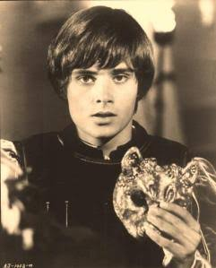
Section 4: Betrayal & The Secret Plan (Act 3, Scene 2 – Act 4, Scene 1)
- [ ] Romeo and Juliet manage to spend their wedding night together in Juliet's bedroom before he leaves for Mantua.
- [ ] Juliet’s parents decide she must marry Count Paris in two days to cheer her up after Tybalt's death.
- [ ] Lord Capulet threatens to disown Juliet and throw her out on the street if she refuses to marry Paris.
- [ ] The Nurse advises Juliet to remain loyal to Romeo and run away to Mantua.
- [ ] Feeling betrayed by the Nurse, Juliet goes to Friar Laurence for help.
- [ ] Friar Laurence gives Juliet a potion that will make her appear dead for 42 hours.
- [ ] According to the Friar's plan, Juliet will wake up in her family’s tomb, where Romeo will be waiting for her.
- [ ] Friar Laurence sends Friar John to deliver a letter explaining the entire plan to Romeo in Mantua.

Section 5: The Sleeping Draught & The Tomb (Act 4, Scene 2 – Act 5, Scene 2)
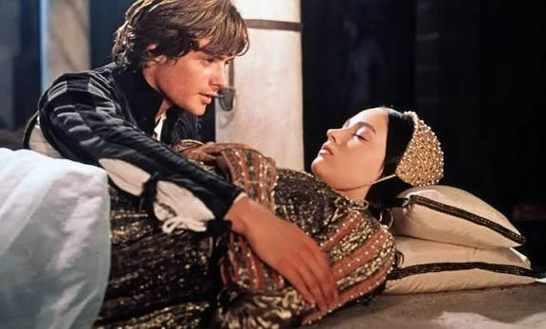
- [ ] Juliet apologizes to her father and pretends to agree to marry Paris.
- [ ] On the night before her wedding, Juliet drinks the Friar’s potion without any fear or hesitation.
- [ ] The Nurse finds Juliet "dead" in her bed on the morning of her wedding to Paris.
- [ ] The Capulet family changes Juliet's wedding preparations into funeral arrangements.
- [ ] Friar John successfully delivers the letter about the sleeping potion to Romeo in Mantua.
- [ ] Balthasar (Romeo's servant) arrives in Mantua and falsely tells Romeo that Juliet is dead.
- [ ] Romeo buys poison from an apothecary so he can end his life next to Juliet in her tomb.

Section 6: The Climax & Resolution (Act 5, Scene 3)
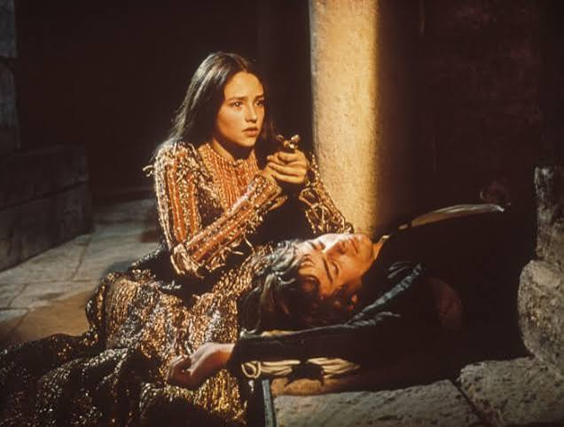
- [ ] Romeo breaks into the Capulet tomb, drinks the poison, and dies next to Juliet.
- [ ] Juliet wakes up from her deep sleep just before Romeo drinks the poison.
- [ ] When Juliet discovers Romeo is dead, she uses his dagger to end her own life.
- [ ] Friar Laurence stays in the tomb and saves Juliet before the guards arrive.
- [ ] At the end of the film, the Capulets and Montagues realize the tragic cost of their feud and agree to make peace.

36

Let’s Remember: Memory Recall Quiz
A.Choose the best answer (A, B, or C) for each question based on what you saw in Zeffirelli's film.

1. What song is sung during the party scene at the Capulet home when Romeo and Juliet first meet?
A) "A Time for Us" B) "What Is a Youth?" C) "Love is a Flower"

2. Where does Romeo hide when he hears Benvolio and Mercutio calling for him after the party?
A) Under a bridge in the town square
B) Behind a tree in the Capulets' garden orchard
C) Inside Friar Laurence’s chapel

3. What physical object does the Nurse bring to Juliet after her secret wedding night with Romeo?
A) A gold ring B) A rope ladder C) A written letter from the Prince

4. How does Mercutio react right after Tybalt stabs him under Romeo’s arm?
A) He dies immediately without saying a word.
B) He thinks it’s just a scratch at first and jokes, before cursing both families.
C) He screams for help and begs the Prince to kill Tybalt.

5. Why couldn't Friar John deliver the crucial letter about the potion to Romeo in Mantua?
A) He was robbed by bandits on the road.
B) He lost the letter in the river.
C) He was trapped inside a house due to a plague quarantine.
B.Match the scene description in Column A with the correct detail or character in Column B.
Column A (Scene Description) | Column B (Detail / Character)
1. He wears a fiery red/orange outfit and has a fierce, angry personality. | A. Friar Laurence
2. The location where the famous street fight and Mercutio's death take place. | B. Olivia Hussey (Juliet)
3. She was only 15 years old during filming, making her emotional scenes very realistic. | C. Tybalt
4. He holds a basket of herbs and plants when we first meet him in his garden. | D. The Sunlit Town Square
5. The weapon Juliet uses when she wakes up and sees Romeo dead. | E. Romeo’s Dagger
C. OVER TO YOU: Answer the questions below based on your own opinion of the movie!

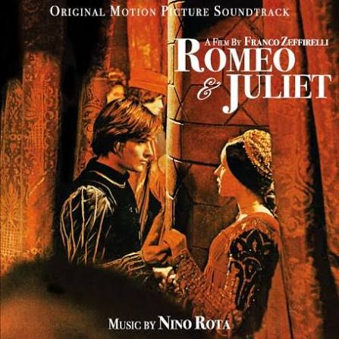
1. The Rating: Give Zeffirelli’s Romeo and Juliet (1968) a rating out of 5 stars: ⭐ ⭐ ⭐ ⭐ ⭐

2. What was the BEST part of the movie?
- [ ] The street fights and sword duels (Mercutio vs. Tybalt)
- [ ] The romantic scenes (The Balcony scene & Secret Wedding)
- [ ] The costumes and real Italian locations
- [ ] The music and soundtrack
- [ ] Other: ___________________________________________________________

3.What was your LEAST favorite part?
- [ ] The old-fashioned Shakespearean language was hard to follow.
- [ ] The ending was too sad/frustrating.
- [ ] The pacing felt slow in certain scenes.
- [ ] Other: ___________________________________________________________
The Young Cast: Did you like that the director chose actual teenagers (Leonard Whiting & Olivia Hussey) to play Romeo and Juliet? Did their acting feel natural to you?
__________________________________________________________________________________
The Frustration Factor: Which character's decision frustrated you the most, and why? (e.g., Romeo's impulsive temper, the Friar's risky plan, Lord Capulet's anger) 37

Let’s Practice: REPHRASING ON TENSES
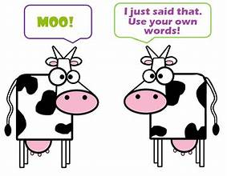
1. I finished my homework. Then I went to the cinema. After……………………………..………………………………….....

2. In my opinion, Pavarotti was the greatest opera singer. I……………………………….………………………………………….

3. He stopped speaking to us two months ago. He…………………………………………….………………………………………….

4. Who does that book belong to? (owns) …………………………………………………………………………………………………….
5. He worked 40 years for the same company. Then he retired. When he…………………….………………………………

6. Once I played football, but I don’t play anymore.(used) ……………………………..…………………………………………….

7. The last time her boss paid her was 2 months ago. Her boss……………………………….……………………………….…..

8. They started arguing 2 hours ago and they’re still arguing. (been) ……………………….…………………………………..

9. Will this be your first trip to Rome? (before) ………………………………………………….…………………………………………

10. Do you have any experience in writing essays? (ever) …………………………………..………………………………………..

11. David bought the car some time ago and he still has it. (had) ………………………..………………………………………

12. I haven’t bought a new book for two years. It’s…………………………………………………..……………………….………….

13. I can’t find her phone number now and I thought it was here. (lost) ……………………….…………………………….

14. I heard it on the news and at once I phoned to tell you. As soon as............................................................

15. Ron plans to leave for Rome next Wednesday. (is) …………………………………………………………………………………

16. The weight of this box is 3 kilos. This box…………………………………………………………………………………………………

17. That was the first time Ashley had tasted raw fish. (never) …………………………………………………………………….

18. We will discuss it during the lesson. (while) …………………………………………………………………………………………….

19. When the meeting was over, they went out for a drink. (finished) ………………………………………………………..

20. I’ve never read such a funny book before. (ever) ……………………………………………………………………… 38

